Salesforce Commerce for B2B Set Up Guide

(Time Expected: ~16 hours)

Last Updated March, 2022 by Andrea Bowman

Contents

Section 1: Setup 3

Part A: Initial Setup (Pre-Work) 3

Part B: Org-Wide Defaults and Object Layouts (Pre-Work) 6

Part C: Permission Sets: Buyer, Buyer Manager and Account Switcher (Pre-Work) 11

Section 2: Create Sample Data 17

Part A: Create Products 17

Part B: Create Price Book 18

Part C: Create Price Book Entries 18

Section 3: Store Creation and Mapping 20

Part A: Store Creation with B2B Template 20

Part B: Community and CMS Channel Mapping 22

Part C: Catalog and Categories 26

Part D: Add Product and Category Media 30

Section 4: Get Ready to Activate 34

Part A: Accounts, Contacts and BuyerGroups 34

Part B: Catalog, Buyer Group and Price Book Association to Store 42

Part C: Commerce Entitlement Policies 45

Part D: Build Search Index 48

Section 5: Customize Experience Builder Components 50

Part A: Product Detail Page - Product Detail Data Card 50

Section 6: Configure Checkout 52

Part A: Clone From Template and Builder Mapping 52

**Part B: Register Classes** 54

**Part C: Store Integration Service** 57

Part D: Activate Store 58

Section 8: Explore the Storefront 60

Part A: Access B2B Run time as Buyer 60

Part B: Create and Assign Contact Point Addresses 63

# Section 1: Setup

## Part A: Initial Setup (Pre-Work)

1. Enable Communities by going to Setup > Digital Experiences > Settings
   1. Check the ​**Enable Digital Experiences** ​checkbox:
   2. Choose a domain name relevant for the B2B Commerce Lightning Store you are building such as: <FirstnameLastname>AIMTraining
   3. Click the ​**Check Availability**​ button
      1. Wait for the ​*Success! Domain name available* ​message to come back, picking something else if the domain you picked is unavailable
   4. Click ​**Save** ​and ​**Approve the dialog**​ and if you receive a warning about ​*Open this Page*​ proceed by clicking ​**Open**
   5. You should see a success message like ​*Success! You can now create new digital experiences.*
   6. Go to Setup > Digital Experiences > Settings again
   7. Under **Role and User Settings** section Check ​**Allow using**​ **standard external profiles for self-registration and user creation**
      1. Allow using standard external profiles for self-registration and user creation: **Checked**​
      2. Confirm any warnings to proceed
   8. Click Save

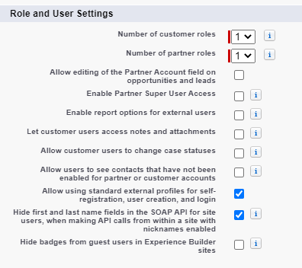

1. **Enable Commerce**
   1. Go to Setup > Commerce > Settings
   2. Select **Enable Commerce**
   3. Click **Save**
2. **Enable Order Preferences**:​
   1. Go to Setup > Order Settings
   2. Check the two preferences confirming any dialogs along the way:
      1. Enable Enhanced Commerce Orders: **Checked**​
      2. Enable Optional Price Books for Orders: **Checked**​

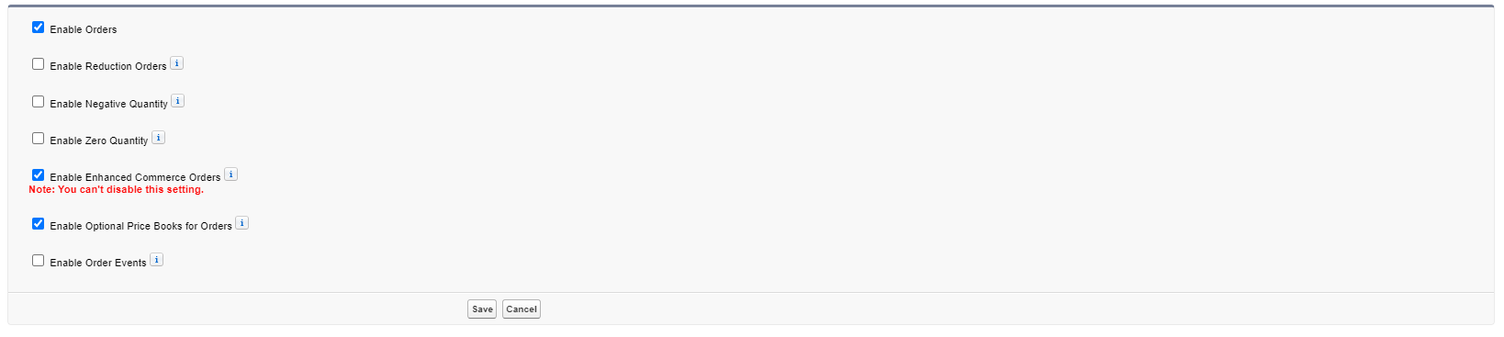

* 1. Click **Save**​

**Note:**​ The Enhanced Commerce Setting cannot be disabled, but is necessary for B2B​ Commerce on Lightning Experience to work seamlessly on Core.

1. **Enable and Activate CMS**:​
   1. Go to Setup > Profiles

b.

Click

​

**Edit**

​

next to

​

**System Administrator**

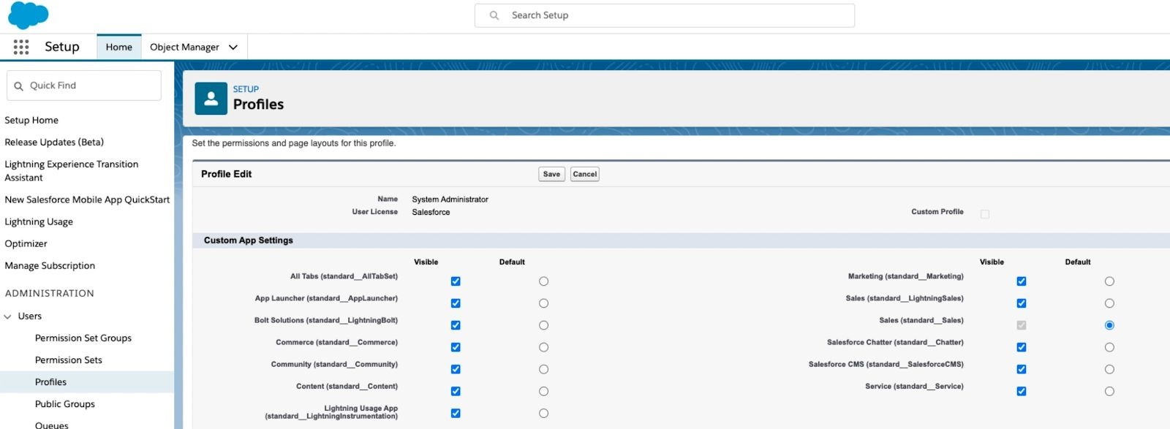

c. Go to Custom App Settings

* + 1. Digital Experiences CMS (standard_SalesforceCMS): **Visible**​

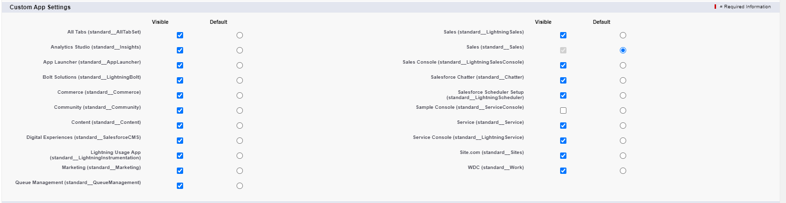

d. Go to Tab Settings

i. Switch to **Default On**​ ​ instead of​ ​ **Tab Hidden**​ for these 3 CMS items:​

* + - 1. CMS Channels
      2. CMS Workspaces
      3. Digital Experience Home

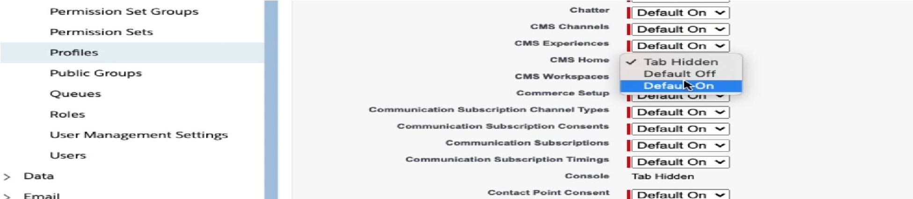

e. Go to Administrative Permissions

i. Ensure that ​**Create CMS Workspaces and Channels**​ is checked



f. Click ​**Save**

1. ​**Verify CMS App**​ by going to App Launcher > Digital Experiences App:
   1. Verify that CMS ​**Workspaces**​, Digital Experiences ​**Home** ​and CMS ​**Channels** are visible in the​ App:

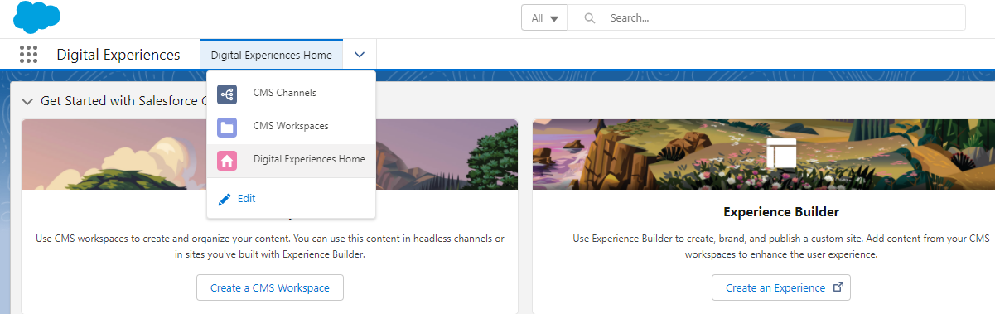

* 1. If they are not present, double-check this step in the section ​7 - Enable and Activate CMS​**:** 
     1. Digital Experiences (standard_SalesforceCMS): ​**Visible**

## Part B: Org-Wide Defaults and Object Layouts (Pre-Work)

1. **Set Org-Wide Defaults** by going to Setup > Sharing Settings​
   1. Setup > Sharing Settings
   2. Click **Edit**​
   3. Set both Default Internal Access​ (left) and ​Default External Access​ (right) as​ **Public Read Only** for these objects:​
      1. Catalog
      2. Electronic Media Group
      3. Order Delivery Method
2. Click **Save**

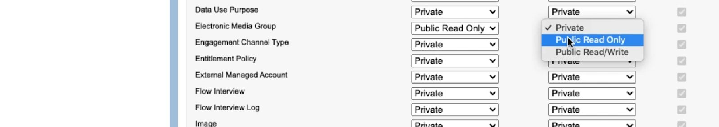

1. **Update Product Layout**​ by going to Setup > Object Manager > Product > Page Layouts

> Product Layout

* + 1. Drag ​**Product SKU**​ and **Product Class** from the Fields to the ​**Product Detail**​ section:

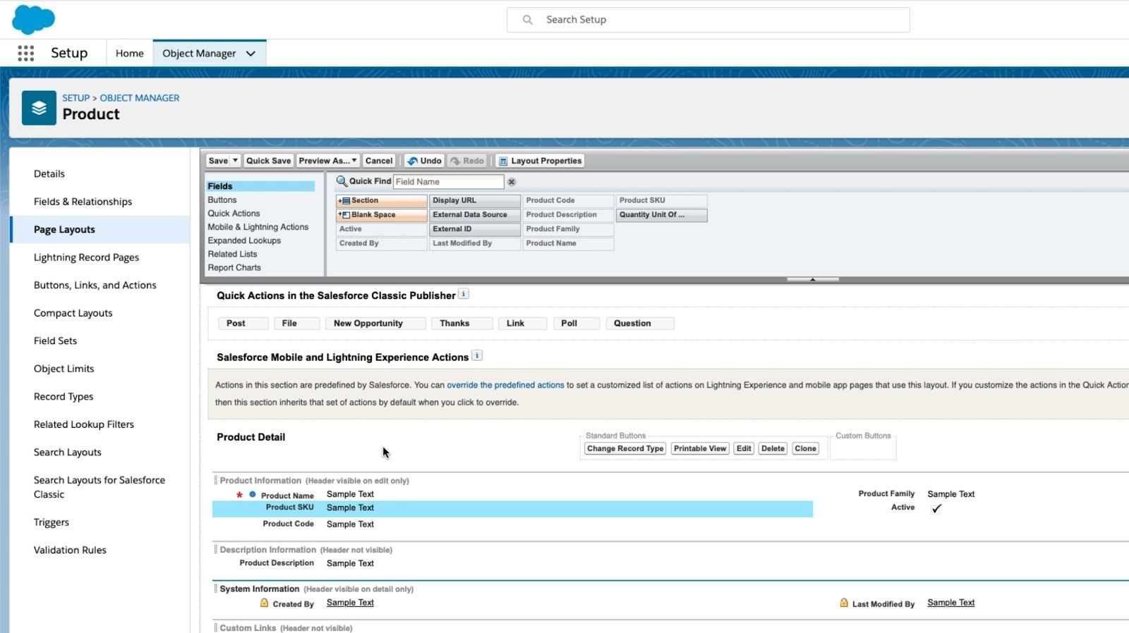

* + 1. Click ​**Related Lists**​ (top section)
    2. Drag ​**Categories**​ and ​**Commerce Entitlement Policies**​ down to the Related

Lists section (bottom section)

* + 1. Click ​**Save**​ and click ​**Yes**​ to any dialog about overwriting Related List

Customizations

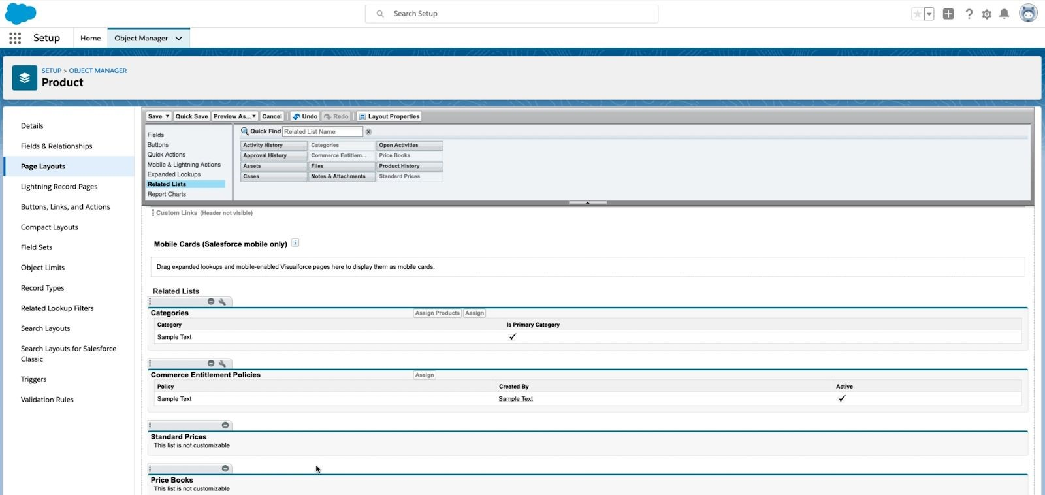

* + 1. Click ​**Save**

1. **Update Order Delivery Group Summary Page Layout**​ by going to​​Setup > Object Manager > Order Delivery Group Summary > Page Layouts > Order Delivery Group

Summary Layout

* + 1. In Order Product Summaries Related List > Click on ​**wrench icon**
    2. Customize fields to display
    3. Add ​**Product Name**​ field into list of displayed columns

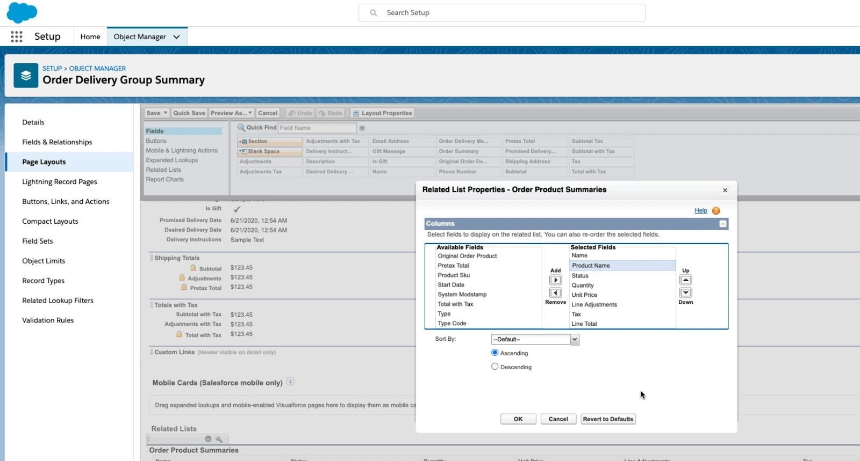

d.

Click

​

**OK**

e. Click ​**Save**

1. **Update Account Layout**​ by going to Setup > Object Manager > Account > Page

Layouts > Account Layout

* 1. Click ​**Related Lists**
  2. Drag ​**Contact Point Addresses, Carts**​ and ​**Community Members**​ into the Related

Lists section (bottom section)

* 1. Click ​**Save**

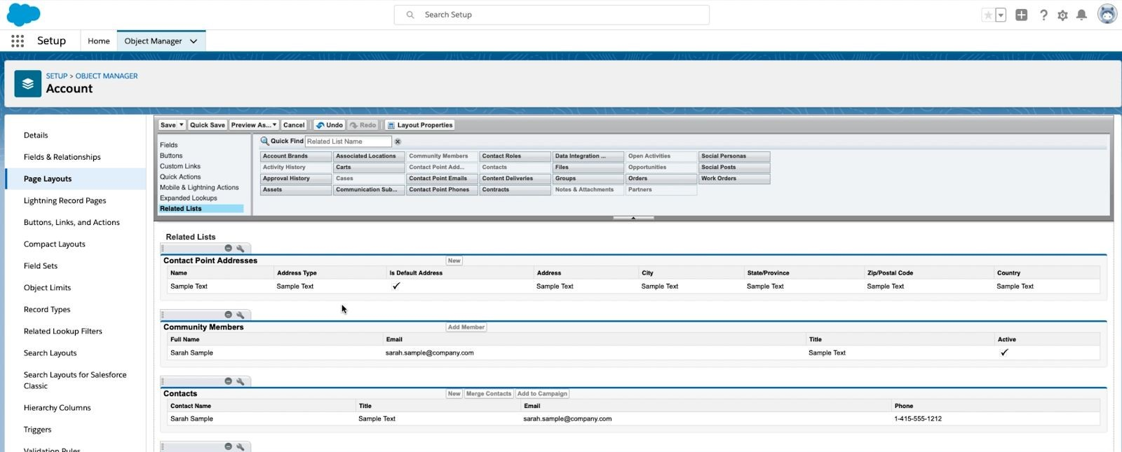

* 1. Confirm the dialog about *Overwrite Users’ Related List Customizations*​ by clicking **Yes**​:​

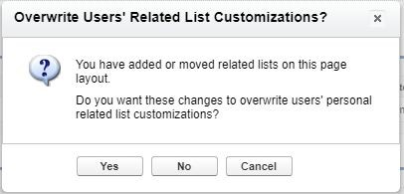

e.

Go to App Launcher > Accounts

i. List view: **All Accounts**​

1. Select any Account (Acme)
2. Click on Setup Gear in top menu
3. Click **Edit Page**​
4. Click the **Details** tab
5. Search for **Buyer Account**​ component (on left) and drag it to bottom of the page and the region will turn green:

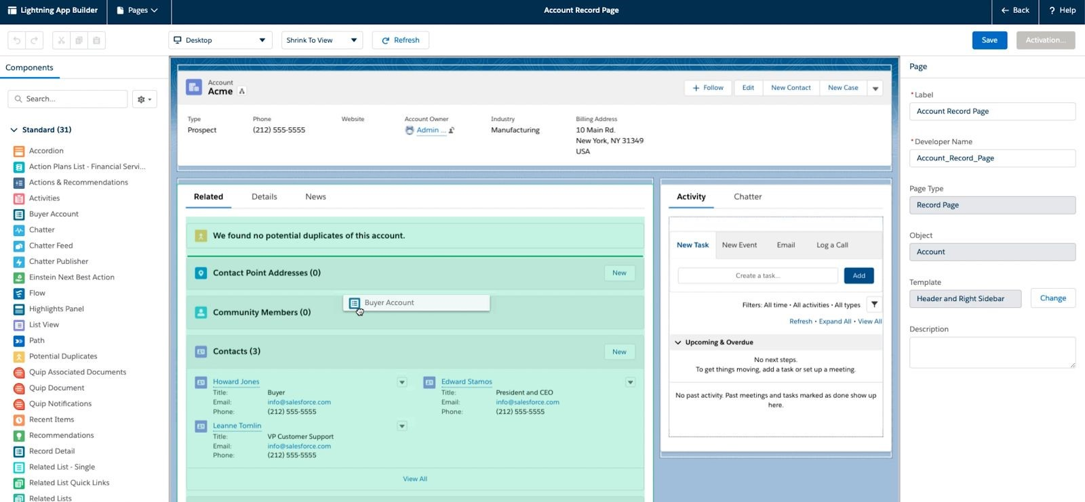

1. It should look like this at bottom after dragging it out:

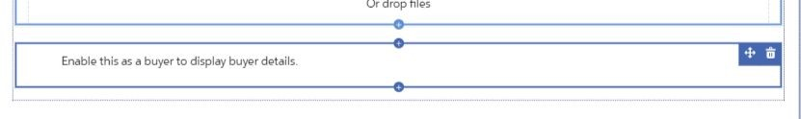

k.

Click

​

**Save**

​

(

top right

)

* 1. Click ​**Activate** ​button
  2. Click ​**Assign as Org Default**​ button
  3. Choose ​**Desktop and Phone**
  4. Click ​**Next**
  5. Click ​**Save**
  6. Click ​**Back** ​(top left) to go back to the Account page

## Part C: Permission Sets: Buyer, Buyer Manager and Account Switcher (Pre-Work)

1. **Create Permission Set B2B Commerce User**​ (for B2B Buyer User) by going to Setup > Permission Sets:

1. **PLEASE NOTE: There are OOTB “Buyer” and “Buyer Manager” permission sets provided for B2B, but these have a very specific level of access and do not allow adding additional access to other objects or additional system permissions. We will be creating our own Permission Sets for Buyers and Buyer Managers so that we have more flexibility moving forward.**
2. Click ​**New**
3. Create a new Permission set
   1. Label: ​**B2B Commerce User** ​(tab for autocomplete)
   2. API Name: ​**B2B_Commerce_User**
   3. Session Activate Required: ​**Unchecked**
   4. License: ​**Customer Community Plus**

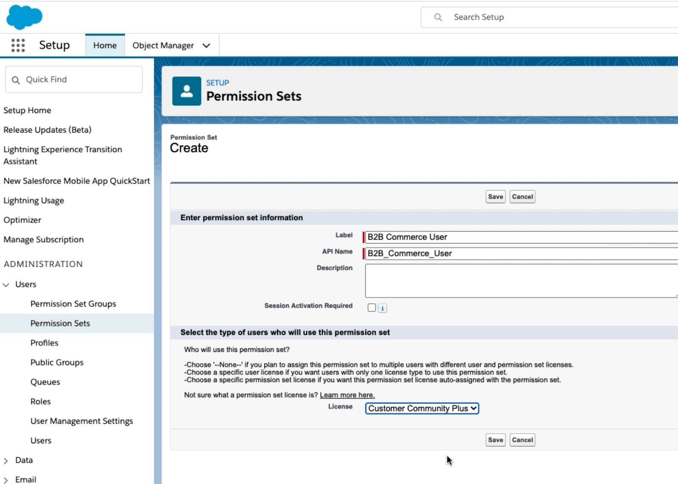

1. Click ​**Save**
2. Click ​**Object Settings**​ under the ​**Apps**​ section
3. Assign ​**Read** ​access to ​**all**​​of the objects below (see picture for quick route after clicking Edit):

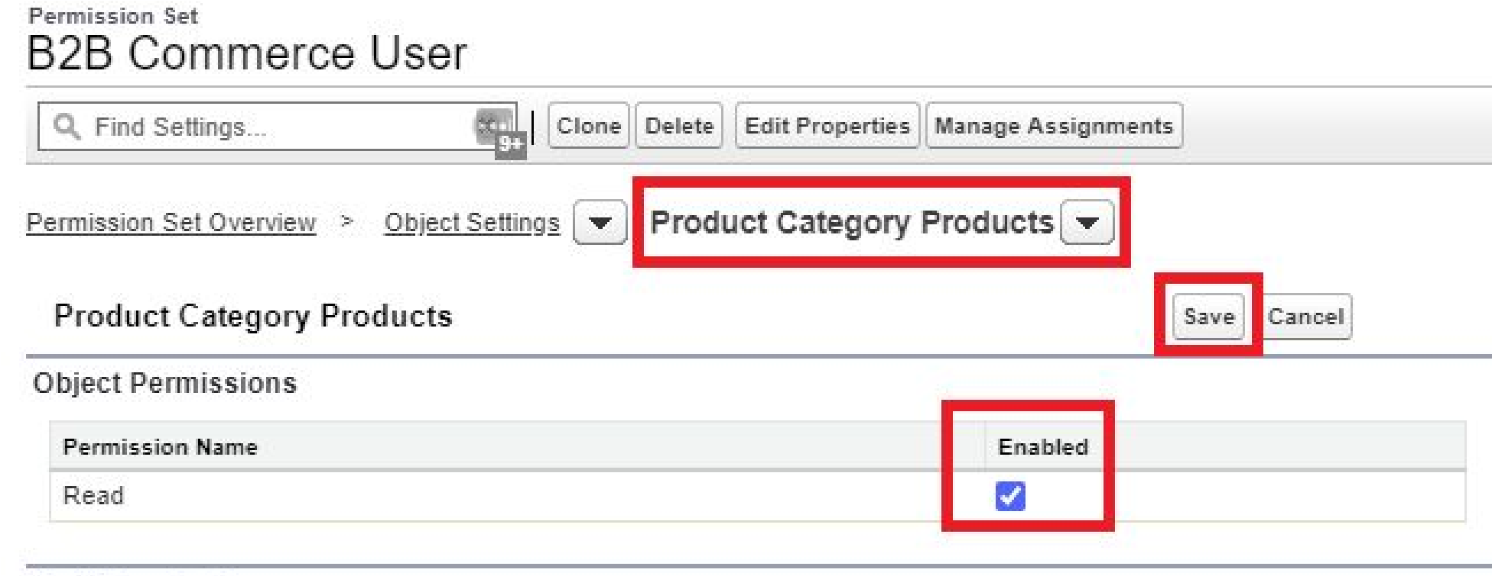

i.

Accounts

* 1. Buyer Accounts
  2. Catalogs
  3. Categories
  4. Electronic Media Groups
  5. Images
  6. Individuals
  7. Locations
  8. Order Delivery Methods
  9. Order Summaries
  10. Price Books
  11. Products
  12. Product Category Products
  13. Stores
  14. Store Catalogs

**\*\*\*\* TRIPLE CHECK THESE 😊\*\*\*\*\*\*\***

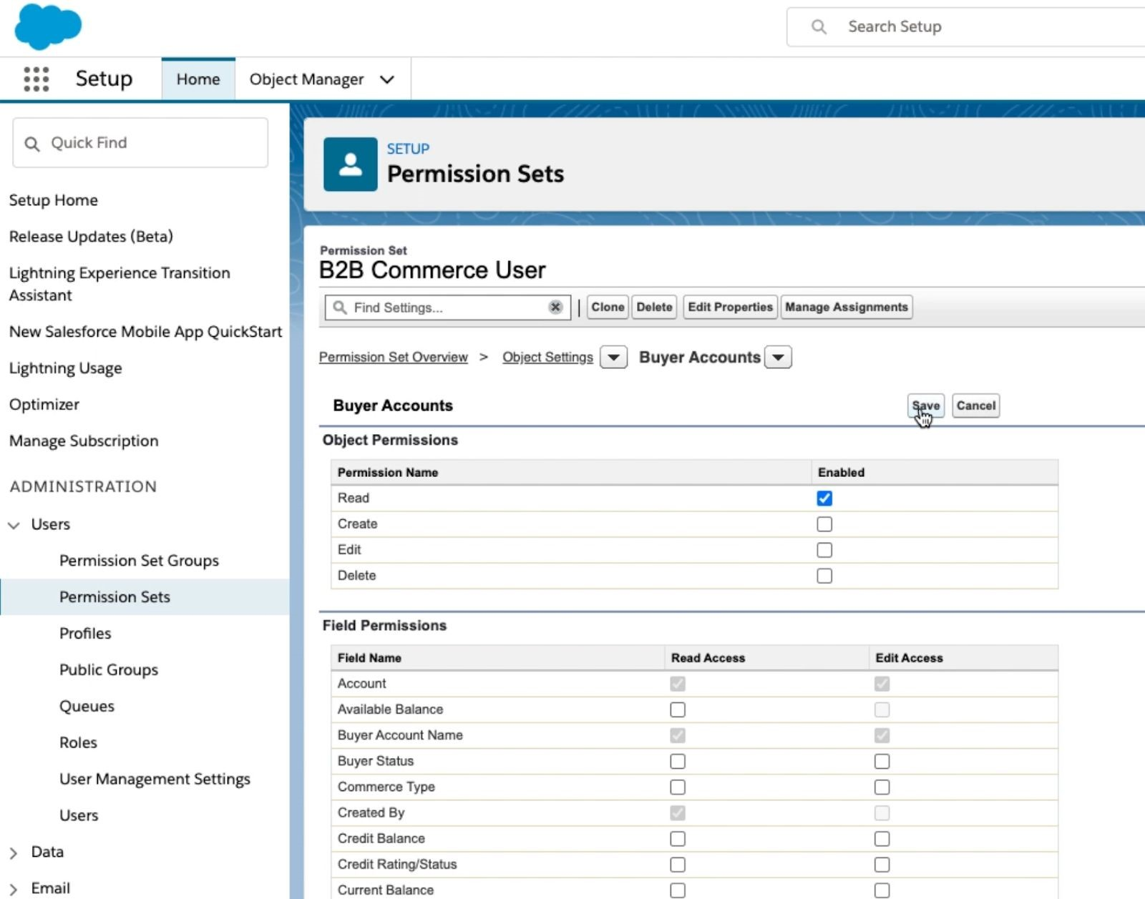

1. Assign **Read and Edit** access to **Contacts**
2. Assign the colloquial ‘full CRUD access’ to the objects below (**Read,**​  **Create, Edit -and- Delete)**:​
   * + 1. Carts
       2. Contact Point Addresses

3.

Orders

4.

Wishlists

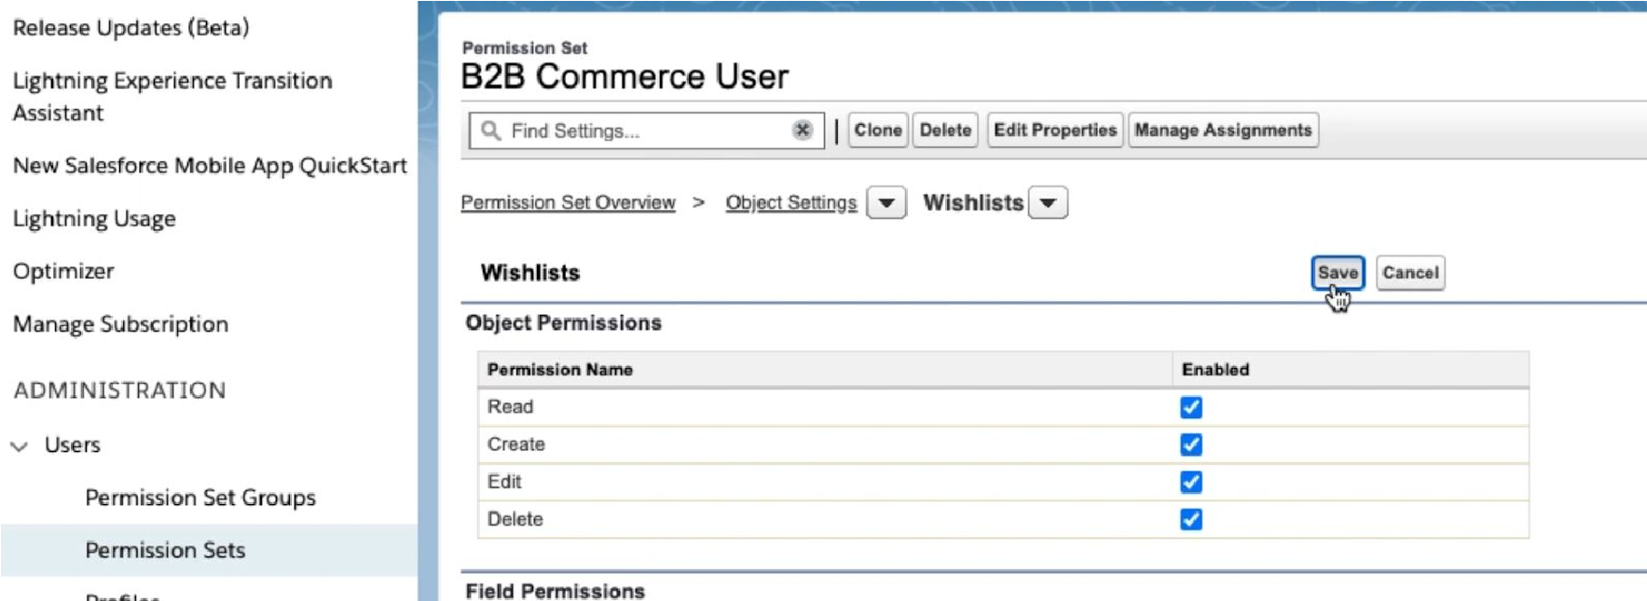

1. Click Object Settings (underlined) > Contact Point Address
2. Add Read Access to All Fields under Field Permissions:

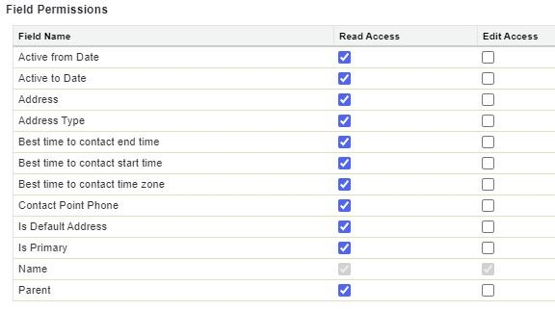

i.

Click

​

**Save**

* + 1. Click ​**Permission Set Overview**​ (underlined)
    2. Go to System section and click ​**System Permissions**
    3. Click ​**Edit**
    4. Enable checkboxes for ​**Commerce User, Payments Api User, Manage Account Addresses**​ ​and ​**Run Flows**​**:**





n.

Click

​

**Save**

o. Confirm the dialog by clicking ​**Save**

1. **Create Permission Set B2B Commerce Buyer Manager** by going to Setup > Permission Sets
   1. Make a clone of the ​**B2B Commerce User**​ permission set you created above by clicking ​**Clone** ​(left):
      1. Label: ​**B2B Commerce Manager User**
      2. API Name: ​**B2B_Commerce_Manager_User**
      3. Session Activation Required: ​**Unchecked**
      4. License as ​**Customer Community Plus**
   2. Click ​**Save**
   3. Click on ​**B2B Commerce Manager User**
   4. Click on ​**System Permissions**​ in the System section (bottom)
   5. Click ​**Edit**
   6. Enable ​**B2B Commerce Super User, Create and Customize Reports** and **Run Reports**​:



g. Click ​**Save**

* 1. Confirm the dialog by clicking ​**Save**​ again
  2. Click on **Object Settings**
  3. Grant **Read, Create,** and **Edit** permission to **Contacts**
  4. Click on ​**Permission Set Overview**​ (underlined)
  5. Click on ​**App Permissions**​ in the ​**Apps**​ section
  6. Click ​**Edit**
  7. Select ​**Delegated External User Administrator**

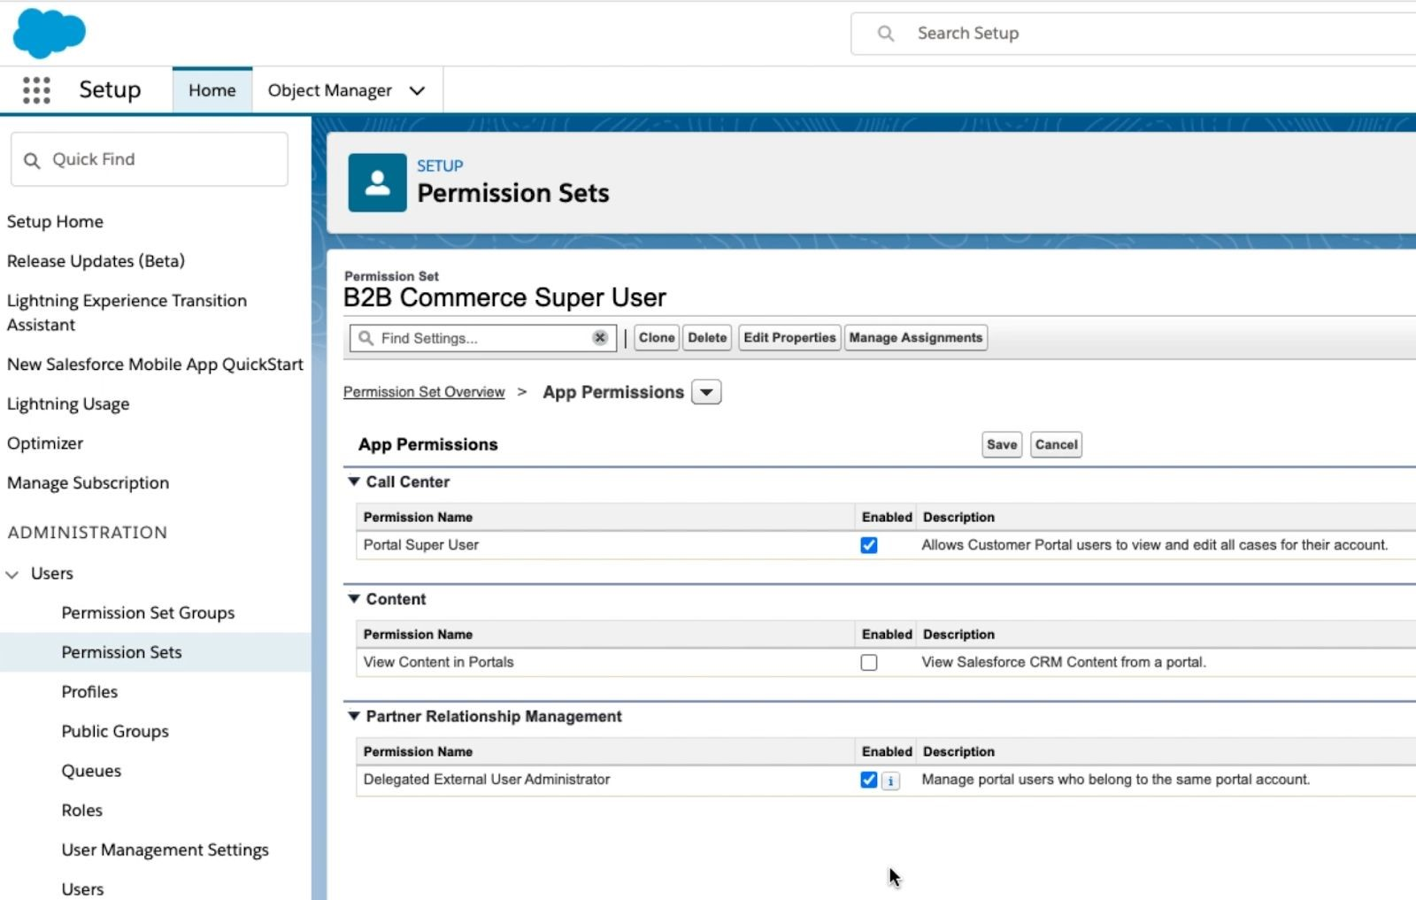

m.

Click

​

**Save**

n. Confirm the dialog by clicking ​**Save**​ again

# Section 2: Create Sample Data

## Part A: Create Products

1. Got to Setup > Object Manager > Product
2. Click **Fields and Relationships**
3. Click **New**
4. Select **Picklist**
   1. Field label: **Color**
   2. Values: **Enter Values**
   3. Input 2-4 colors that will correspond to the products you create later in this section
5. Click **Next**
6. Click **Visible** at the top to make the field visible for all profiles
7. Click **Next**
8. Click **Save**
9. Go to App Launcher > Commerce
10. Click ​**Products** ​in the main navigation
    1. If you do not see **Products** in the main navigation:
       1. Click **Edit** > **Add More Items** > search for **Products** and then **Add Nav Item**
11. Click “New” in the upper right hand corner
    1. Input Fields
       1. Product Name
       2. Color
       3. Product Code
       4. Product SKU
       5. Product Description
       6. Active: **Checked**
       7. Please Note: Product Code and Product SKU must be the same
12. Click Save
    1. **Repeat above steps to create 3 more products**

## Part B: Create Price Book

1. Go to App Launcher > Commerce
2. Click **Price Books** in the main navigation
3. Click “New” in the upper right hand corner
   1. Input Fields
      1. Price Book Name
      2. Description
      3. Active: **Checked**
4. Click Save

## Part C: Create Price Book Entries

1. Go to App Launcher > Commerce
2. Click **Products** in the main navigation
3. Select one of the 4 products you created
4. Navigate to the related lists
5. Under “Price Books” click **Add Standard Price**
   1. Input Fields (Product and Price Book should be inputted for you):
      1. List Price
6. Repeat step 6 but now the button should say click **Add to Price Book**
   1. Select the Price Book you created in Part B and USD
   2. Input Fields (Product and Price Book should be inputted for you):
      1. Active: **Checked**
      2. List Price
7. Click Save
   1. **Repeat above steps to add prices to all 4 products**

Part D: Find Product Images

1. Find images that you would like to use for your products (1-3 images for each)
   1. **PLEASE KEEP IN MIND YOUR DEV ORG HAS A MAX STORAGE OF 20 MB FOR FILES/IMAGES. DO NOT UPLOAD LARGE IMAGES. THIS WILL RENDER YOUR ORG UNUSABLE! (It has happened before 😊 so please double check image sizes)**
2. Save them to your computer

Part E: Load Images to CMS Media

1. Go to App Launcher and Click **Digital Experiences**
2. Dismiss the modal dialog if needed and click **Create a CMS Workspace**
   1. Input Name
   2. Click **Next**
   3. Click **Skip** in the Add Channels Panel
   4. Click **Next** in the Add Contributors Panel
   5. Select **English (United States)** and click right chevron to move it to Selected (right side)
   6. Select **English (United States)** for the Default Language (bottom middle)
   7. Choose English (United States) in the right hand column
   8. Click **Next** to get the “Almost there!” dialogue
3. Click **Done**
4. Go to the newly created CMS Workspace
5. Click **Add Content** on the right side of your screen
   1. Click **Image**
   2. Click **Create**
   3. Input Fields
      1. Source: **Upload from Desktop**
      2. Click **Upload Files**
         1. **Select one of the files you saved in Part D**
      3. Title
      4. Content Slug
   4. Click **Save Draft** in the upper right
   5. Click **Publish**
6. **Repeat above steps to add upload all images**

# Section 3: Store Creation and Mapping

## Part A: Store Creation with B2B Template

1.

Go to App Launcher > Commerce

2.

Click Stores

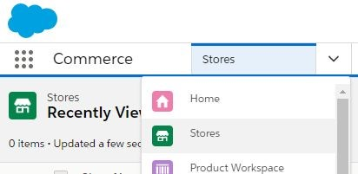

3.

Click

​

**Create a Store**

​

button (top right)

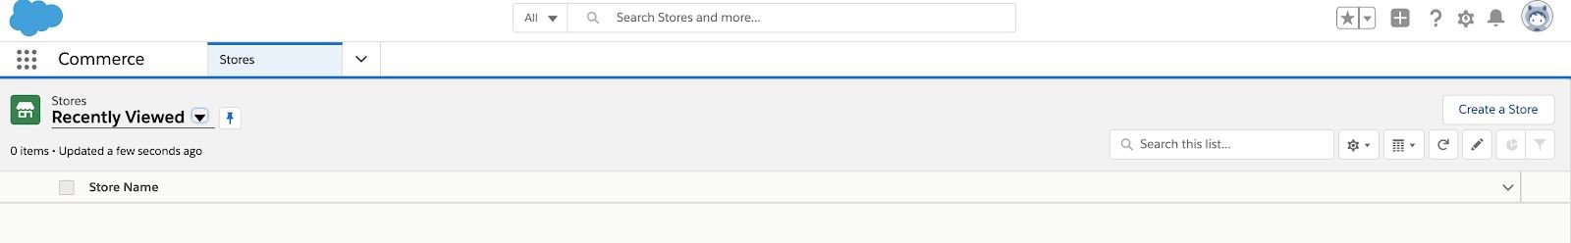

1. Click ​**Get Started**​ button (top right) on the **B2B Commerce Template** (Make sure you select B2B and not B2C)​**:**

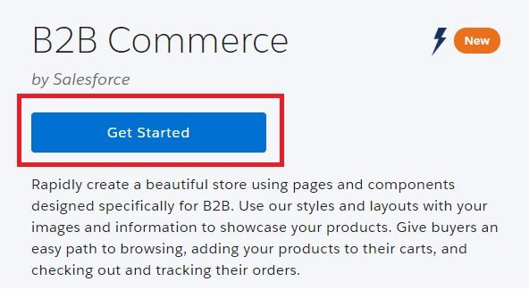

* 1. Input Store Name (**Do not use any apostrophes here**! Ex. **Andrea’s Store** must be **Andreas Store**)

b.

Input URL (optional on right)

​

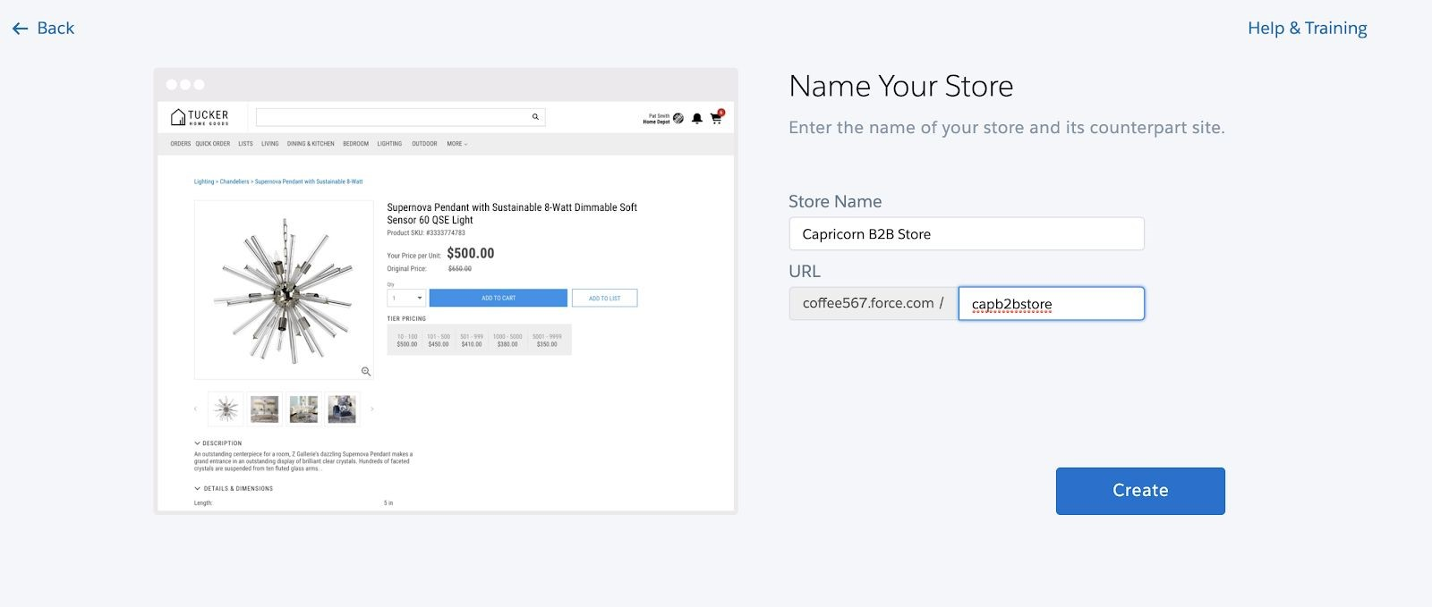

1. Click ​**Create**​ button.
2. You will get a “Not Long now…” screen and eventually land on the Store Home Page​**:**

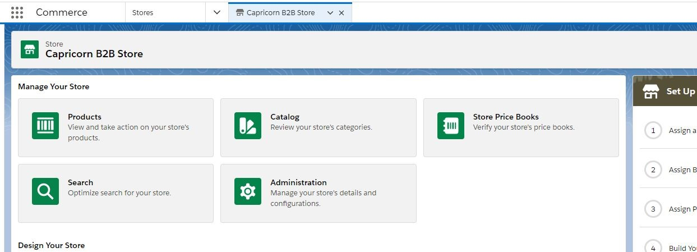

## Part B: Community and CMS Channel Mapping

1. **Access Community Administration**​​by clicking **Experience Builder**​ ​ in the Store Home Page:

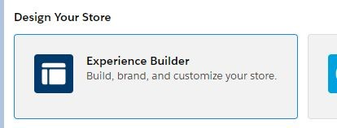

* 1. Wait for Experience Builder to load and then click Settings (gear on left)
  2. You should land on this page.

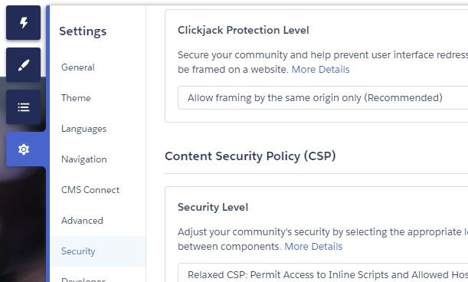

1. Click the ​**Security Tab**
2. Update the ​**Security level**​ setting from ​**Strict: CSP**​ to ​**Relaxed: CSP**
3. Click ​**Allow**
4. **Assign Permission Sets**​ by duplicating the tab you are in and then clicking on the top left icon and clicking ​**Administration**

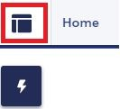

1. Click ​**Members**​ in the left navigation
2. In the section called ​**Select Permission Sets** (half way down) assign all the permission​ sets created so far to the ​**Selected Permission Sets**​ using the right chevron. To be clear, they are:
   1. B2B Commerce User
   2. B2B Commerce Manager User
3. Click ​**Save**

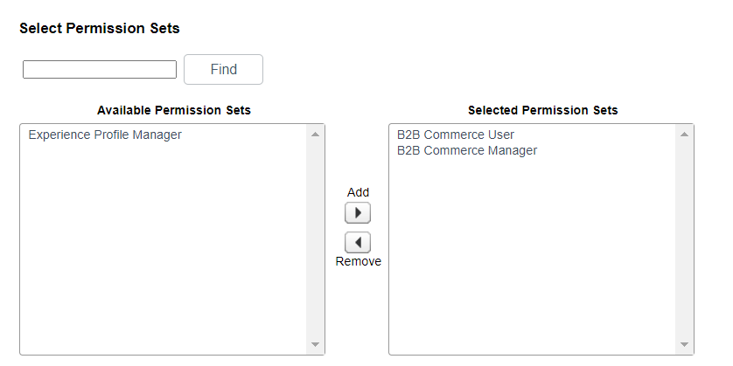

1. Create a Role for Portal Account Owner by going to Setup > Roles
2. If needed, click the **Set Up Roles**​ button to move on​
3. Click Assign to Role
   1. Available Users Search: All User
4. Choose A**dmin User**​ (or your name)​
5. Click right chevron to add to the Selected Users for CEO list:

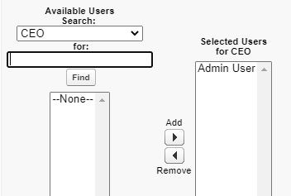

1. Click ​**Save**
2. Assign B2B Store as Channel​ by switching to ​**Digital Experiences**​ via App Launcher
3. Access the CMS Workspace created earlier:
   1. Click CMS Workspaces in the main App navigation
   2. Click ​**your Workspace** in the list of All CMS Workspaces
   3. Click ​**Channels** ​button​​(top right)

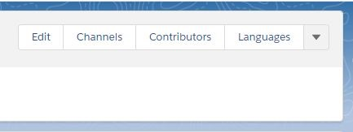

21.

Click

​

**Add Channel button**

​

:

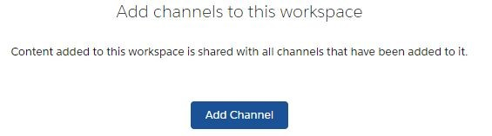

22. Choose your store ​as a channel with the plus icon on left which will turn into a checkbox:

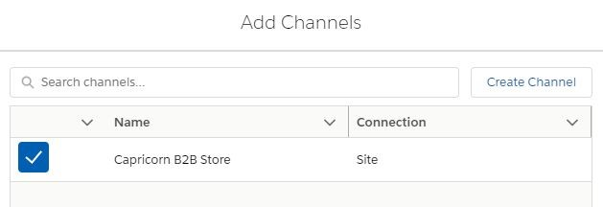

23.

Click

​

**Add**

​

button to get this dialog:

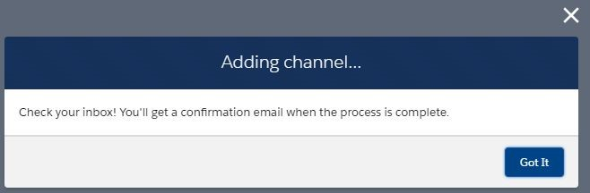

1. Click **Got It**​ button to close out this activity​
2. Eventually you should receive an email with text similar to the below:

We processed your request. Your workspace is ready to share content.

Content items assigned to this channel: 40

## Part C: Catalog and Categories

1. **Start Creating a Catalog** by going to: App Launcher > Commerce​
   1. Click ​**Catalogs** ​in the main navigation:

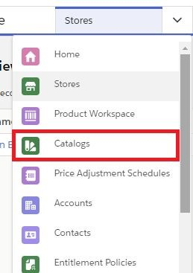

* 1. Click ​the Catalog that was created

1. At this point, you should already be in the Categories tab. ​Create Categories​ by clicking the ​**Create Category**​ button from within the new Catalog you just created:

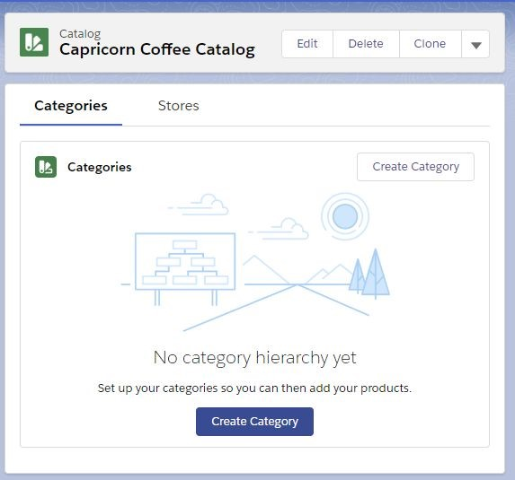

* 1. Create 3 categories for your products. ​**Note**​:​​You may need to close the new tab and then refresh the Catalog tab and click the catalogue again

​ to navigate your way back the first time and the ​**Create**

**Category**​ button moves to the top right after records are created.

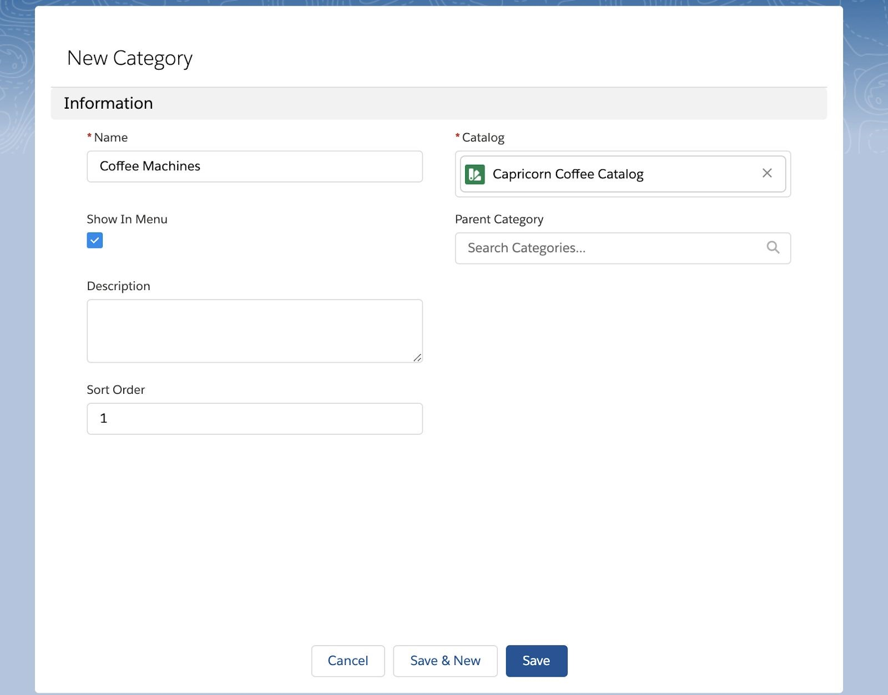

1. **Verify the Category Hierarchy** by closing the three child tabs spawned until you​ get back to your catalogue 
   1. Expand the Category hierarchy view and you should see something like this:

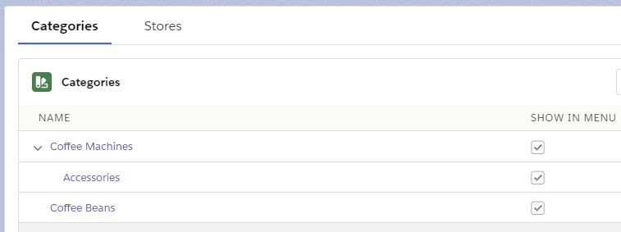

* 1. Select the **Products** category and then **delete** (this was auto-created and we will not be using it)

## Part D: Add Product and Category Media

1. **Add Product Detail and List Images**​. By going to App Launcher > Product Workspace
   1. Click on a product

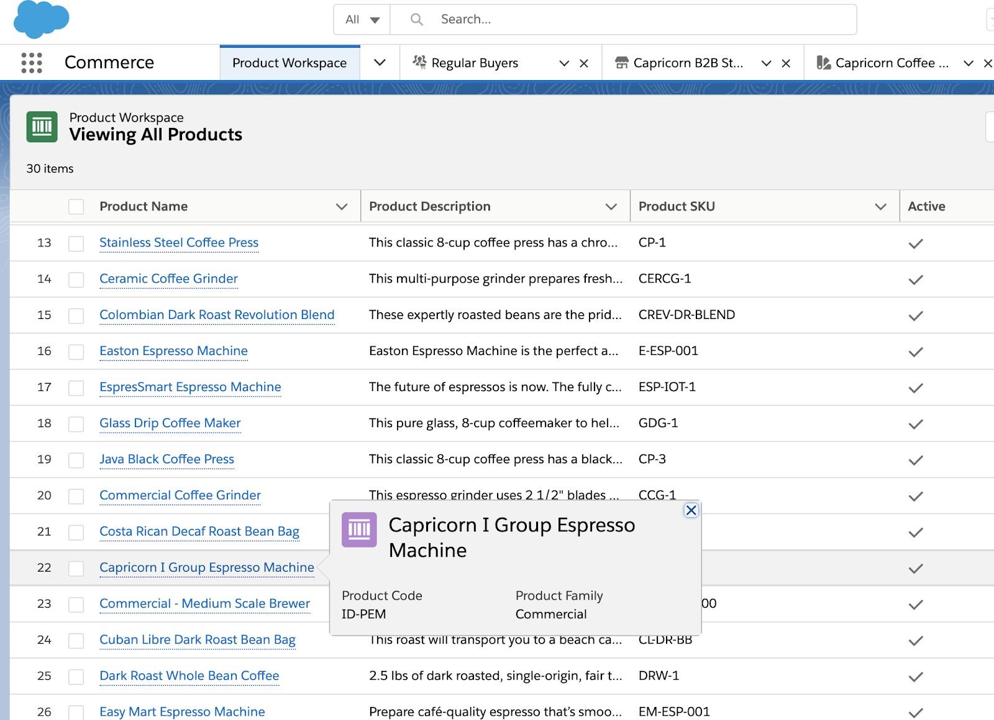

* 1. Click the ​**Media**​ tab
  2. Click the blue ​**Add Image**​ button:

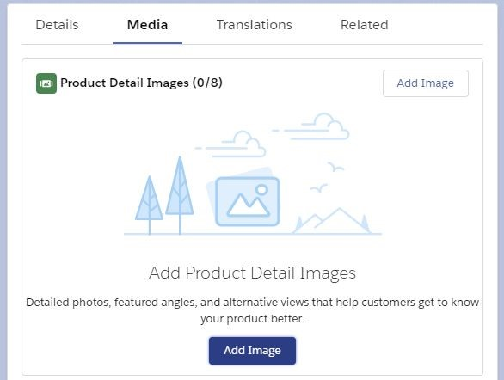

* 1. Select the appropriate image you uploaded earlier for this product

1. Repeat the same actions for Product List Image (scroll down to the next tile) applying one image:

a.

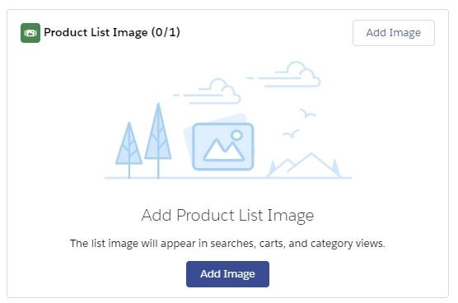

b.

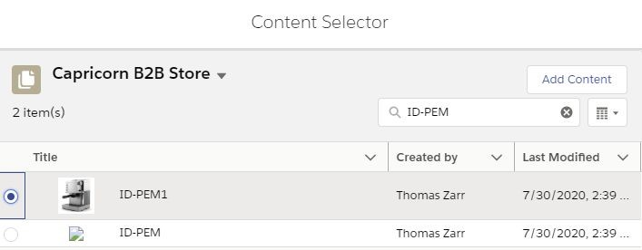

c.

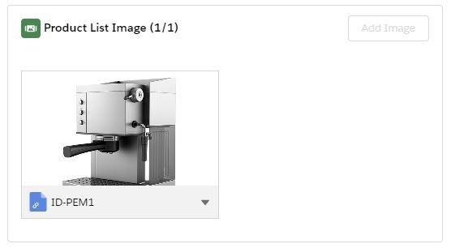

1. Repeat steps 1 (Product Detail Images) and 2 (Product List Image) above for as needed for each product.
2. Now we can ​**Assign Products to Categories**​ by clicking Main Navigation > Catalog
3. Click ​your catalogue
4. Click ​your first category
5. On the right hand side, Click on the chevron next to ​**Products (0)**​ and click ​**Assign Products**​:

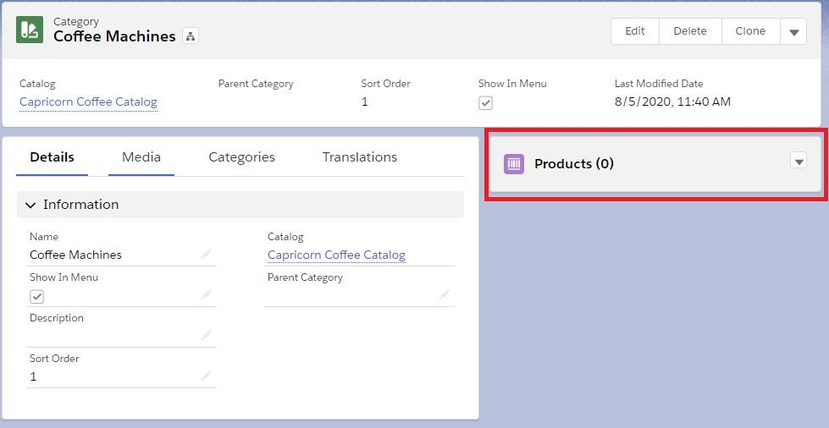

1. Choose the Products you want to assign to the corresponding category
2. Click ​**Next** ​and click ​**Save**:​

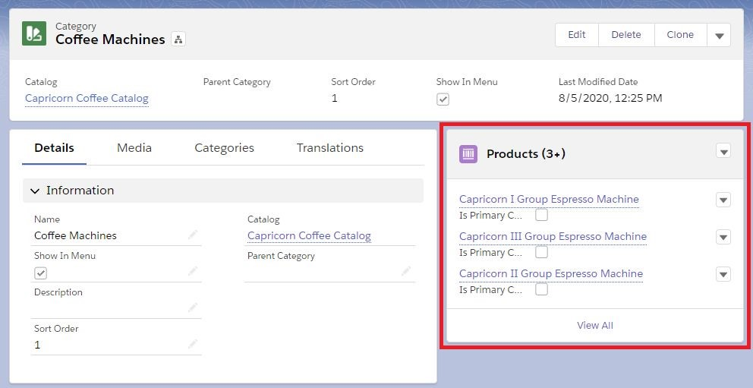

1. **Repeat until each product has been assigned to a category**

# Section 4: Get Ready to Activate

## Part A: Accounts, Contacts and BuyerGroups

1. **Create an Account**​ by going to App Launcher > Commerce
   * 1. Main Navigation > Click ​**Accounts**​:

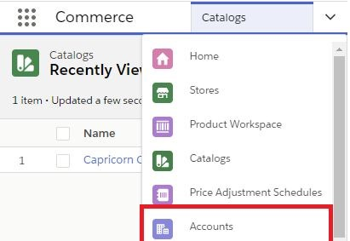

* + 1. Click the ​**New**​ button at top left of the screen
    2. Input Fields (will be referred to as Account A in the remainder of the guide but be as creative as you like here)
       1. Account Name
       2. Account Currency: USD - U.S. Dollar (should be the default or might not show at all. That is also okay 😊)

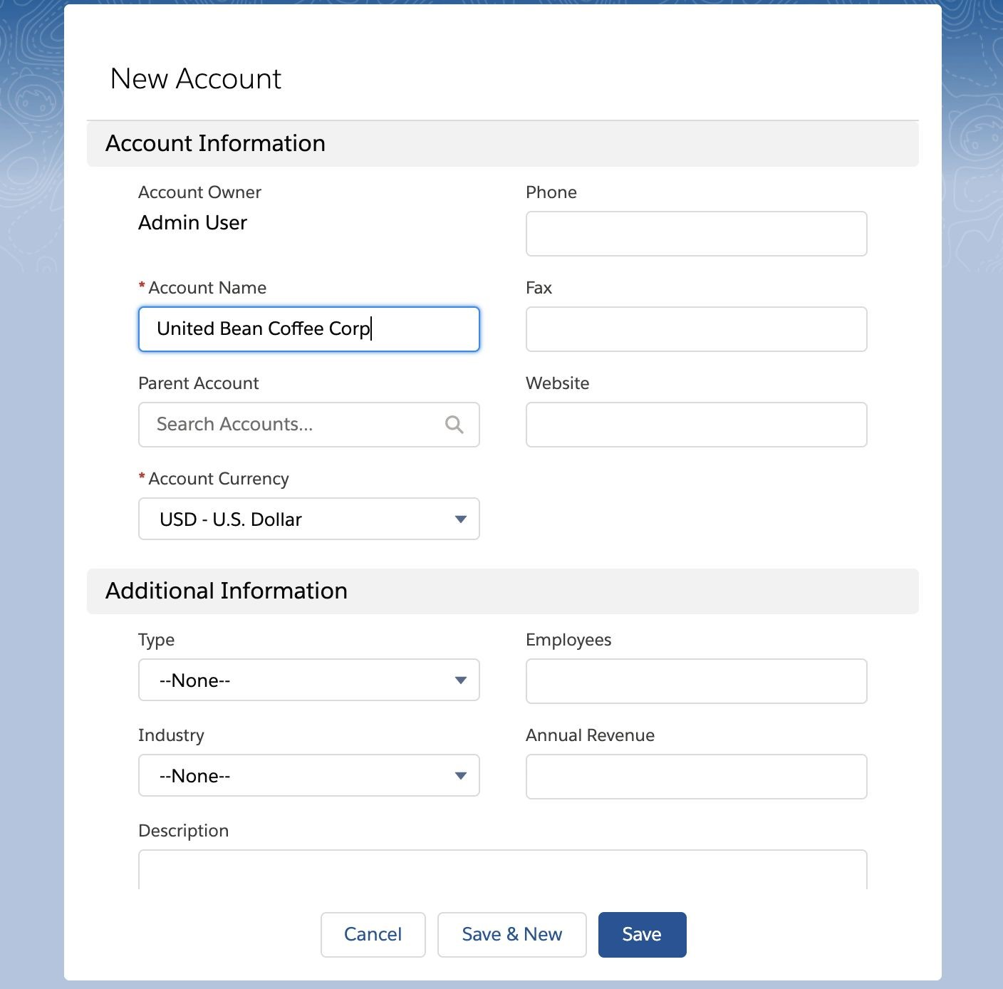

* 1. Click ​**Save**
  2. Create a second Account using the same process above
  3. Input Fields (will be referred to as Account B in the remainder of the guide but be as creative as you like here)
     + 1. Account Name
       2. Account Currency: USD - U.S. Dollar (should be the default or might not show at all. That is also okay 😊)

1. Enable the ​**Account B** ​Account​​as a buyer Account
   1. Click down chevron at top right of screen
   2. Click ​**Enable as Buyer**
      1. If you don’t see this button you will need to add it to the page layout. This should be something you know how to do at this point 😊
   3. Confirm the dialog by clicking the blue ​**Enable as Buyer**​ button:

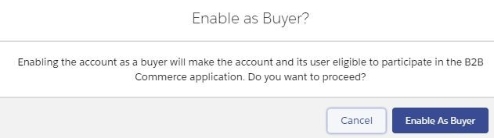

1. Enable the ​**Account A**​ Account as a Buyer by first clicking on ​**Accounts** tab so we can get a list of accounts
   1. Click ​ **Account A**
   2. Click down chevron at top right of screen
   3. Click ​**Enable as Buyer**
   4. Confirm the dialog by clicking the blue ​**Enable as Buyer**​ button
   5. Verify that you can see the new Buyer Account information section populated in the ​ **Account A** ​ Account detail page after this (scroll down):

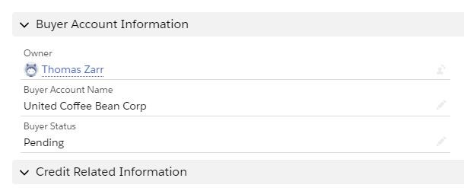

1. Create ​2 contacts​ on the ​ **Account A** Account
   1. Click on the ​ **Account A** ​ tab
   2. Click the ​**Contacts (0)**​ text in the related list:

:

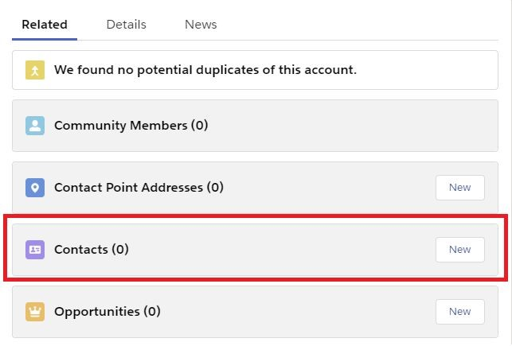

c.

Click

​

**New**

​

button at top right

* + - * 1. Input Fields (will be referred to as Contact 1 in the remainder of the guide but be as creative as you like here)
        2. First Name
        3. Last Name
        4. Email: ​**Use your email address**
        5. Click ​**Save**
    1. Click on the ​**Contacts**​ tab
    2. Click ​**New** ​button at top right
       - 1. Input Fields (will be referred to as Contact 2 in the remainder of the guide but be as creative as you like here)
         2. First Name
         3. Last Name
         4. Email: **​Use your email address**
         5. Click ​**Save**

1. Create ​1 contact​ on the ​**Account B** Account
   * 1. Click on the ​ **Account B** ​ tab
     2. Click the ​**Contacts (0)**​ text in the related list
     3. Click ​**New** ​button at top right
        + 1. Input Fields (will be referred to as Contact 3 in the remainder of the guide but be as creative as you like here)
          2. First Name
          3. Last Name
          4. Email: ​**Use your email address**
          5. Click ​**Save**
2. Enable the ‘Customer User’ for the 2 contacts on the **Account A** Account:
   1. Access the contact detail page for ​**Contact 1**
   2. Click the down chevron at top right and click ​**Enable Customer User** (If you do not see this button you will need to add it to the page layout)
      1. Input fields:
      2. User License: ​**Customer Community Plus**
      3. Alias
      4. Nickname
      5. Click ​**Save**​ and confirm any dialogs to proceed by clicking the ​**OK**​ button, choosing a unique username if needed

**Troubleshooting Note**​: If you get a message saying the Portal Owner does not have a role you may have missed a prior step. You can fix this by doing the following:

Setup > Users

Click Admin User (or your Name)

Assign the role of CEO to the user and click ​**Save**

* 1. Access the contact detail page for ​**Contact 2**
  2. Click the down chevron at top right and click ​**Enable Customer User**
     1. Input fields:
     2. User License: ​**Customer Community Plus**
     3. Alias
     4. Nickname
     5. Click ​**Save**​ and confirm any dialogs to proceed by clicking the ​**OK**​ button, choosing a unique username if needed

1. Enable the ‘Customer User’ for the contact on the **Account B** Account:
   1. Access the contact detail page for ​**Contact 3**
   2. Click the down chevron at top right and click ​**Enable Customer User**
      1. Input Fields
      2. User License: ​**Customer Community Plus**
      3. Alias
      4. Nickname
      5. Click ​**Save**​ and confirm any dialogs to proceed by clicking the ​**OK**​ button, choosing a unique username if needed
2. **Create the Buyer Groups**​ by going to App Launcher > Commerce
3. Click Buyer Groups in the Main Navigation:

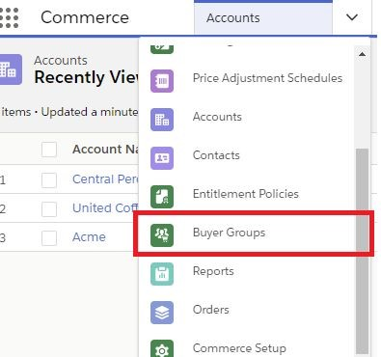

1. Click ​the **Edit** icon next to the already created Buyer Group to edit the Buyer Group Name
   1. Buyer Group Name: ​**Premium Buyers**
   2. Click Save

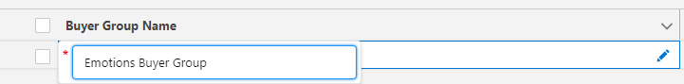

1. Select **Premium Buyer Group**
2. Click the ​**Related**​ tab
3. Click ​**Assign** ​button in the related list ​**Buyer Group Members (0)**​:

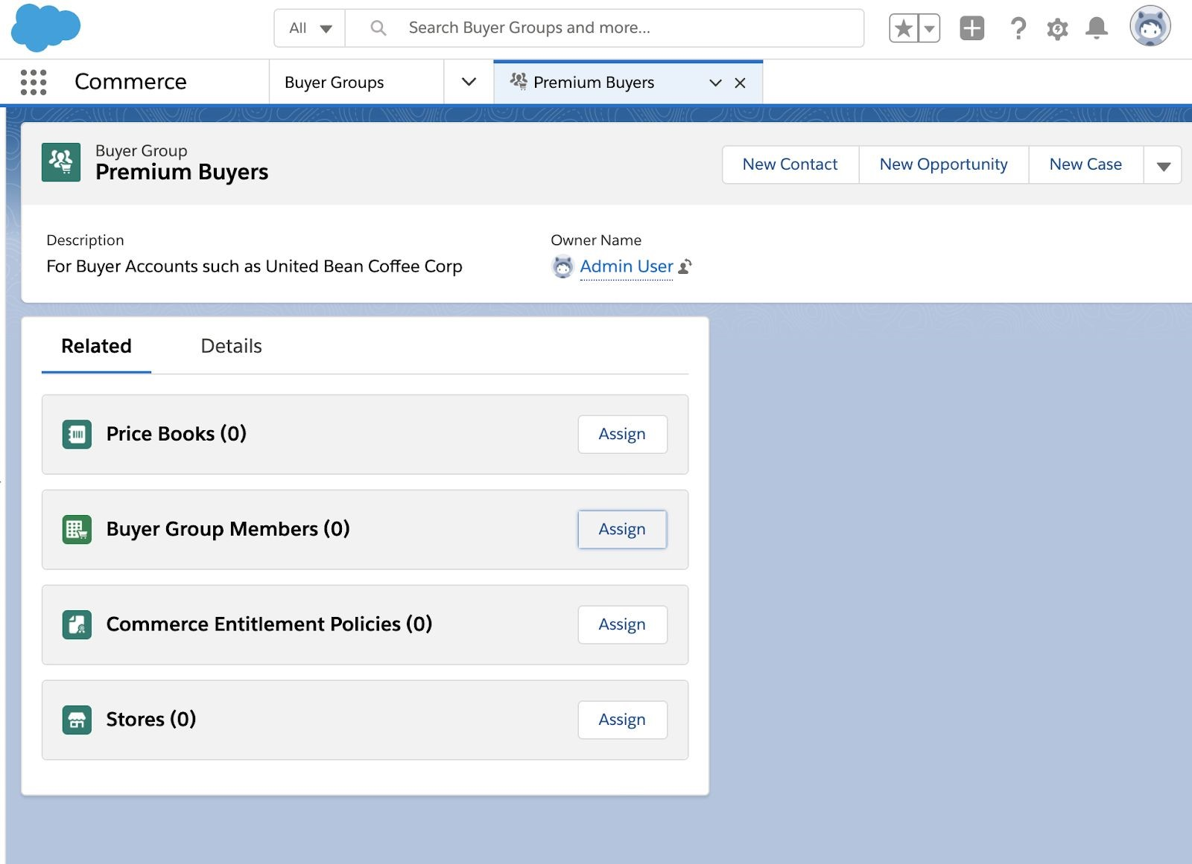

1. Check the plus sign next to ​**Account A**
2. Click ​**Assign**​ button
3. Go back to the ​**Buyer Groups**​ tab
   1. Click ​**New**​ button at top right
4. Buyer Group Name: **Regular Buyers**
   1. Click ​**Save**​ button
   2. Click the ​**Related**​ tab
   3. Click ​**Assign** ​Button in related list ​**Buyer Group Members (0)**
   4. Check the plus sign next to ​**Account B**
   5. Click the ​**Assign**​ button
5. Go back to the Buyer Groups tab and make sure both are present
   1. List View: All Buyer Groups:

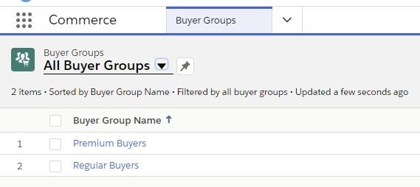

## Part B: Catalog, Buyer Group and Price Book Association to Store

1. Assign a Catalog to a Store by clicking on ​**Stores**​ in the Commerce App main navigation
   * + 1. Click the **Store**​ made earlier
       2. Click the ​**Assign**​ button to the right of ​*Assign a Catalog to Your Store* if it is not already green (it may have done this for you)​:

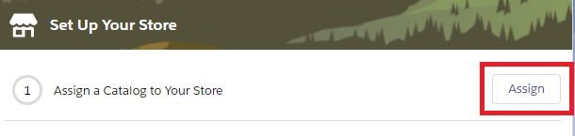

i.

Catalog

ii. Store

c. Click ​**Save**

1. Assign Buyer Group to the Store by going back to the ​**Store…**​ tab (left side)
   1. Click ​**Assign** ​button next to ​*Assign Buyer Groups to Your Store*​:

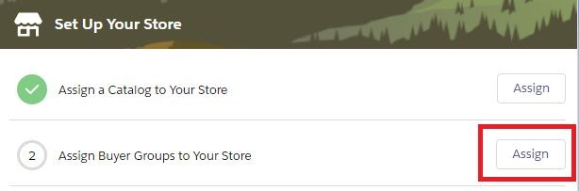

* 1. Choose ​**Regular Buyers** (Premium Buyers Should already be added)
  2. Click the ​**Next**​ button and then click the ​**Save** ​button:

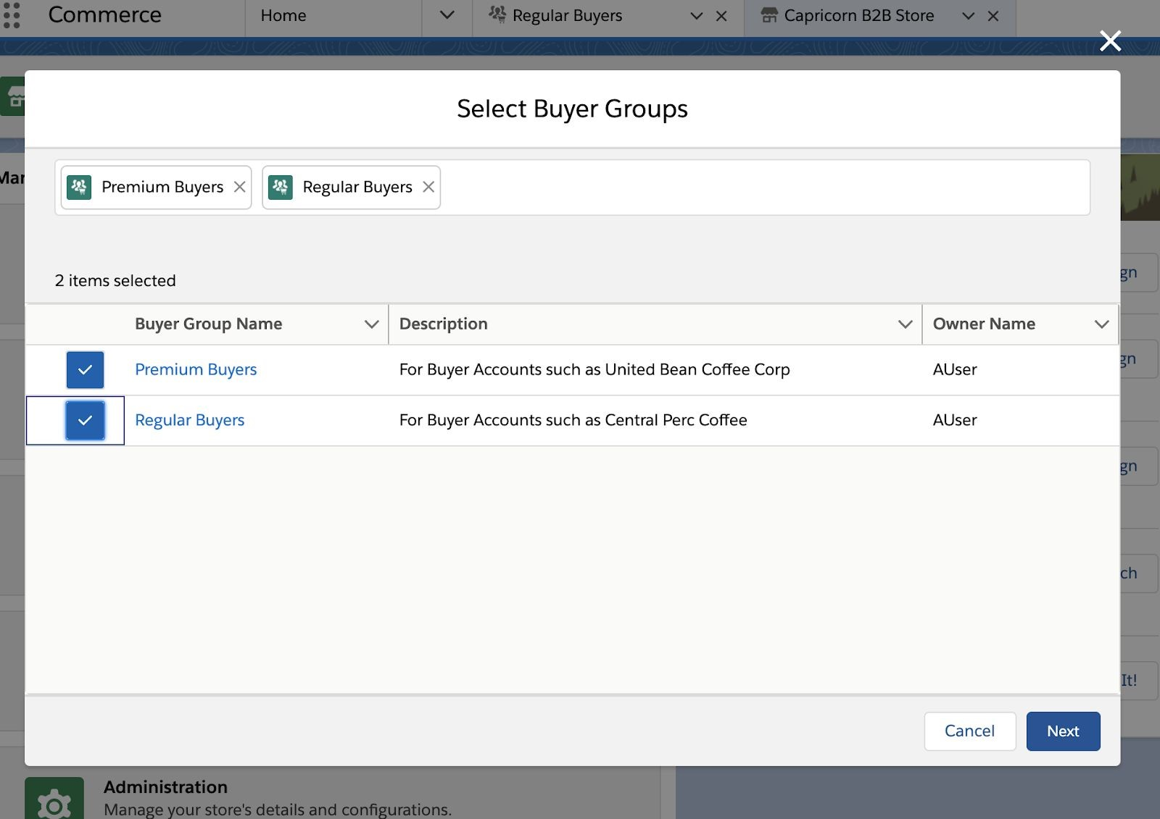

* 1. Your status in the assistant should update accordingly:

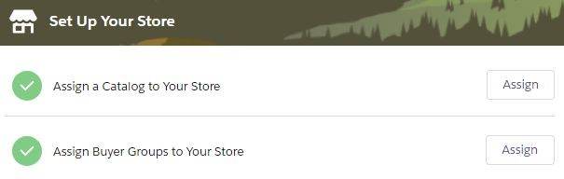

1. Assign the Price Book to the Store by Clicking on ​**Assign** ​button​​to the right of the

*Assign Price Books to Your Store*

* + 1. Price Book​ you created earlier

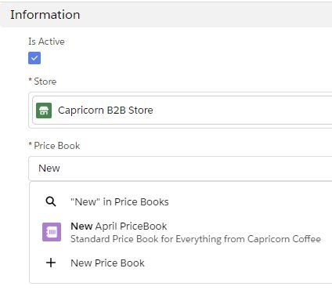

* + 1. Click the ​**Save** ​button

i. Status should update accordingly in the Store if you click on the ​**Store** … tab:​

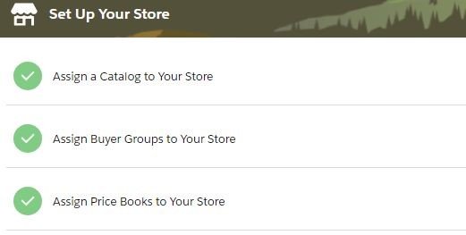

## Part C: Commerce Entitlement Policies

1. **Create Commerce Entitlement Policies**​ by going to Commerce App > Main Navigation and clicking ​**Entitlement Policies**
   1. Click ​**New** ​button (top right)
      1. Name: ​**Premium Entitlement**
      2. Description: ​**Premium Entitlement**
      3. Active: **Checked**​

iv. View Products: **On**​

v.

View prices in catalog:

​

**Checked**

b.

Click

​

**Save**

​

:

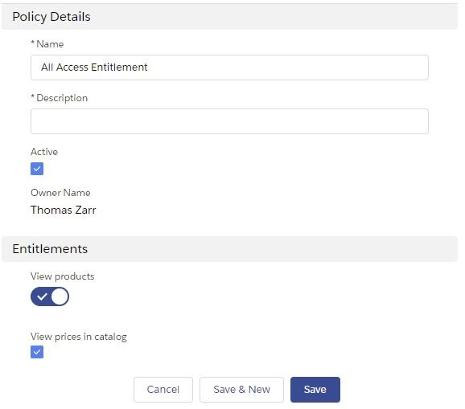

1. **Assign the Entitlement Policy to Products** by clicking the ​**Related**​ tab​
   1. Click on the **Assign**​ button in the ​**Products (0)**​ related list​
   2. Choose all of the products set up prior in the Store Catalog Categories section

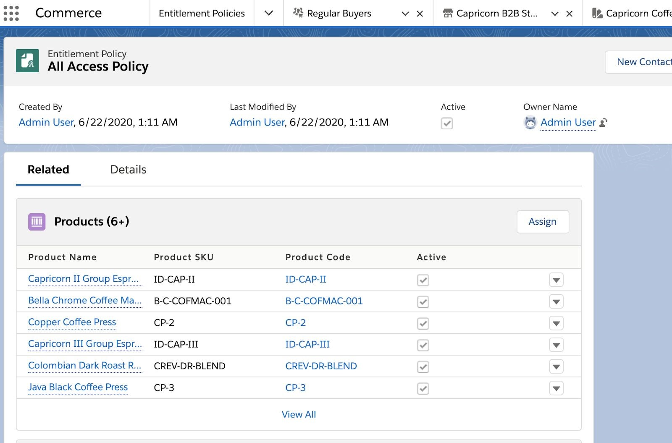

* 1. Click the ​**Assign**​ button and receive a message like ​*X Simple Products Were Added*

1. **Assign Entitlement Policy to Buyer Groups**​ by clicking on the ​**Entitlement Policies** tab
   1. List View: ​**All Entitlement Policies**
   2. Click ​**Premium Entitlement**
   3. Click Related tab
   4. Click the ​**Assign** ​button in the **Buyer Groups (0)**​ related list
   5. Click ​**Premium Buyers** ​to select it
   6. Click ​**Assign** ​button and receive message like ​*Entitlement Policy was assigned to selected Buyer Groups*

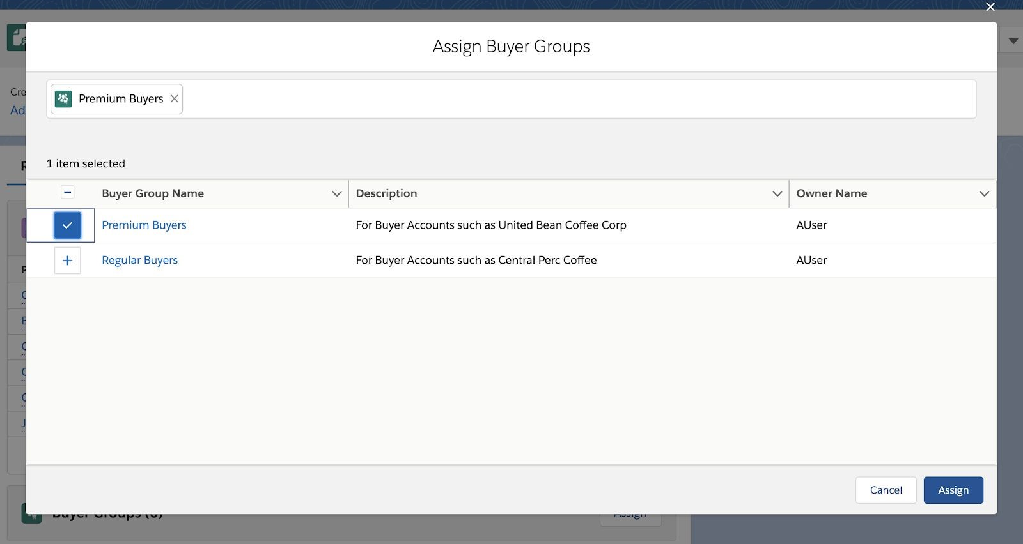

## Part D: Build Search Index

1. **Build the Search Index**​ by going to the Store Home Page in the Commerce App

a. Click on the **Store** you created

b.

Click on the

​

**Search**

​

tile:

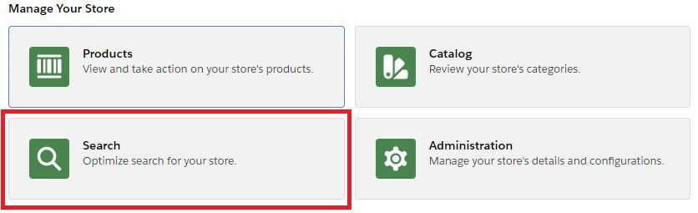

c.

Click on the

​

**Searchable Fields**

​

(on left):

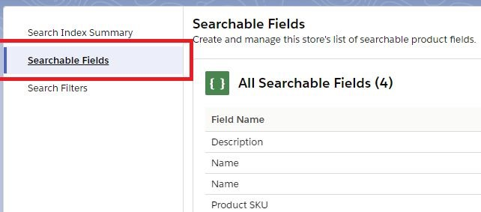

* 1. Click on the ​**Manage Searchable Fields**​ button (right side)
  2. Add additional fields that you would like to search: by adding everything except

Currency ISO code

* 1. Click ​**Save**​ and confirm you received confirmation on screen like: ​*Changes were saved. They'll appear after the next index rebuild.*

1. **Add “Color” to the Left Nav Search Filter**  by clicking on **results filters** (on left)
   1. Click **Manage Filters** button
   2. Click **Color**  under “Select Product Fields” and click right chevron to move under “Selected Fields”
   3. Click **Save**  to see results
2. **Rebuild Index**​ by clicking ​**Search Index Summary**​ (on left)
   1. Click ​**Rebuild Index**​ button (on right)
   2. **Note:**​ You may receive a prompt: “Rebuilding takes up to 4 hours…” Do not be alarmed by the messaging. Our data size is small and this is generically referring to an upper bound:

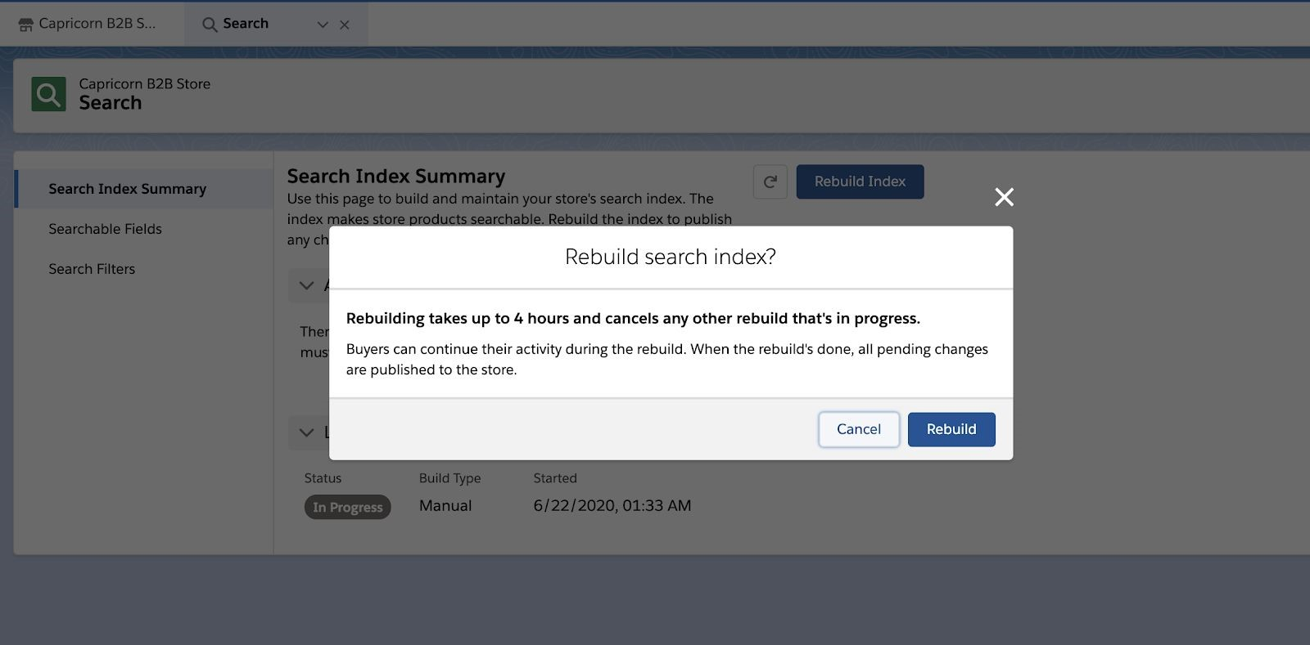

* 1. Click the ​**Rebuild**​ button
  2. **Note**: This page does NOT refresh automatically. Select the Small refresh button to the left of **Rebuild Index** to check if the job has finished

# Section 5: Customize Experience Builder Components

## Part A: Product Detail Page - Product Detail Data Card

1. Navigate to **Experience Builder** by clicking on ​**Stores**​ in the Commerce App main navigation
   1. Click the **Store**​ made earlier
   2. Click the **Experience Builder** tile
2. **Add Custom Fields to the Product Detail Page**​ by choosing Product Detail Page in the main page list in Experience Builder:

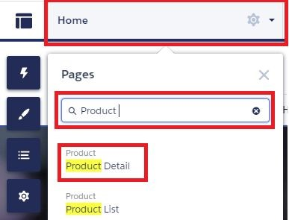

* 1. **Note**: Your screen may display warnings instead of a product – that is because in experience builder it does not know which product is should be displaying

1. **Add “Product Fields Short” Component to the page**​ by clicking on the component (using ​**lighting bolt**​ icon at left) and dragging it on to the page below the Product Detail card:

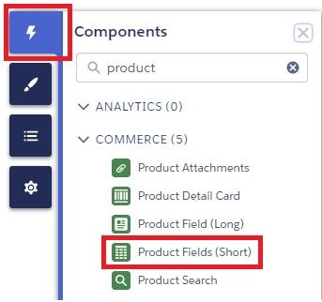

a.

Click on the Product Fields Short component to bring up the left panel of options:

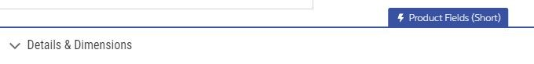

b.

Click

​

**Add Field**

​

button and choose your new field:

* 1. Color

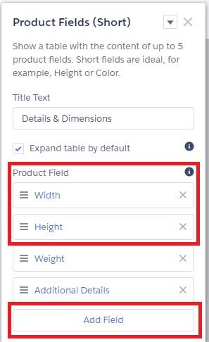

1. Click **Publish**​ (top right) in Experience Builder to publish the changes and click​ the **Publish**​ button to confirm the dialog​
2. Confirm on screen dialog received like: ​*We're publishing your changes now. You'll receive an email confirmation when your changes are live.*
3. Click ​**Got It**​ button
4. Confirm email received like: ​*Congratulations! Capricorn B2B Store was published successfully and is now live on the following domain(s)...*

# Section 6: Configure Checkout

## Part A: Clone From Template and Builder Mapping

1. **Access Checkout Flow Template from Experience Builder**​ by selecting the **Checkout**​ in the list of Pages:

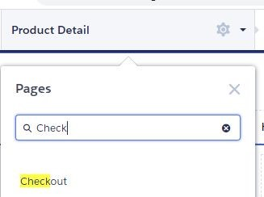

a.

Click on the

​

**Checkout Flow**

​

component (middle of page):

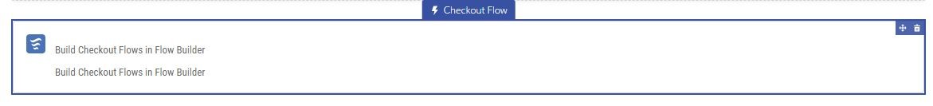

* 1. Click ​**Edit Flow in Flow Builder**​ (on right)
  2. Once the All Flows setup page launches click on ​**Checkout Flow Template**
  3. Click ​**Save As**​ button
     1. Flow Label: ​**My New Checkout**​ (tab through for autocomplete)
     2. Flow API Name: ​**My_New_Checkout**
     3. Click ​**Show Advanced**
     4. How to Run the Flow: ​**System Context with Sharing - Enforces**

**Record-level Access**

* + 1. Type: ​**Checkout Flow**​ (this may be disabled)
  1. Click ​**Save**
  2. Ignore any messages in the ​*Review these issues*​ dialog
  3. Click ​**Activate**​ (top right)

1. **Change the Checkout Component Mapping**​ by going back to Experience Builder
   1. Choose the Checkout page
   2. Click on the ​**Checkout Flow**​ Component to bring up the panel:

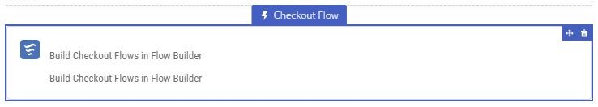

* + 1. Checkout Flow Name: ​**My New Checkout**
  1. Click ​**Publish**​ (top right corner)
  2. Click ​**Publish**​ again on the dialog then click ​**Got it**​ button

## **Part B: Register Classes**

1. **Add the Reference Implementations**​ for Checkout Integration Classes by going to

Setup > Apex Classes

* 1. ​[Course Assets for Parts I & II](https://cognizantonline-my.sharepoint.com/:f:/g/personal/767310_cognizant_com/Egv5Yb3uQX1Em2__4IAH-QABFOTadFU8snoC6B9xvhHX8Q?e=Y8FVMi) (Hosted on Andrea’s Sharepoint)
  2. Locate the 4 files at root level starting with “B2B” and ending with file extension “apxc” and add them to the Apex classes in your org by using these steps:
     1. Click the ​**New**​ button
     2. Paste the file content
     3. Click ​**Save** ​button
     4. Click ​**Apex Classes**​ in left navigation after each one:
        1. B2BShippingSample.apxc
        2. B2BCheckInventorySample.apxc

3.

B2BTaxSample.apxc

4.

B2BPricingSample.apxc

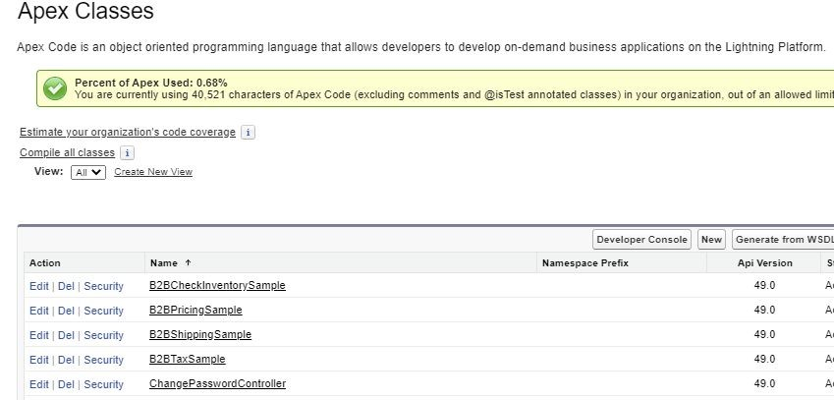

1. **Add Apex Classes into RegisteredExternalService** by following the ​ [full direction](https://developer.salesforce.com/docs/atlas.en-us.b2b_comm_lex_dev.meta/b2b_comm_lex_dev/b2b_comm_lex_integration_setup.htm)​[s here](https://developer.salesforce.com/docs/atlas.en-us.b2b_comm_lex_dev.meta/b2b_comm_lex_dev/b2b_comm_lex_integration_setup.htm) noting that:​
2. **ApiVersion** should be assigned to ​ **54.0**
3. **webstoreName** should be assigned to ​**{YourStoreName}​**
4. **apexClassName** should be assigned to ​**B2BPricingSample**​
5. **registeredDevName** should be assigned to ​**COMPUTE_PRICE​**

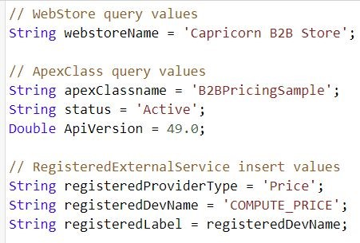

1. Copy the apex source provided making the changes noted
2. Go to Gear Icon (top right) > **Developer Console**​
3. Type Control E or otherwise open **Execute Anonymous**​
4. Click **Execute**​ making sure there are no errors​
5. Repeat the steps above for the other 3 types using the assignments below for each additional iteration:
6. **B2BCheckInventorySample:​** 
   1. apexClassName = **B2BCheckInventorySample**
   2. registeredProviderType = **Inventory**
   3. registeredDevName = **CHECK_INVENTORY**
7. **B2BShippingSample**:​
   1. apexClassName = **B2BShippingSample**
   2. registeredProviderType = **Shipment**
   3. registeredDevName = **COMPUTE_SHIPPING**
8. **B2BTaxSample**:​
   1. apexClassName = **B2BTaxSample**
   2. registeredProviderType = **Tax**
   3. registeredDevName = **COMPUTE_TAXES**
9. Confirm with the following SOQL query that 4 classes were registered by selecting the Query Editor Tab at the bottom of the developer console
10. Paste the below text in the top box:

SELECT Id, ExternalServiceProviderId, ExternalServiceProviderType,

DeveloperName FROM RegisteredExternalService WHERE DeveloperName in ('COMPUTE_PRICE','CHECK_INVENTORY','COMPUTE_SHIPPING','COMPUTE_TAXES'

)

**Note**​: Use this table and the ​[original documentation](https://developer.salesforce.com/docs/atlas.en-us.b2b_comm_lex_dev.meta/b2b_comm_lex_dev/b2b_comm_lex_integration_setup.htm)​ to confirm your mappings if there is any doubt in this section:

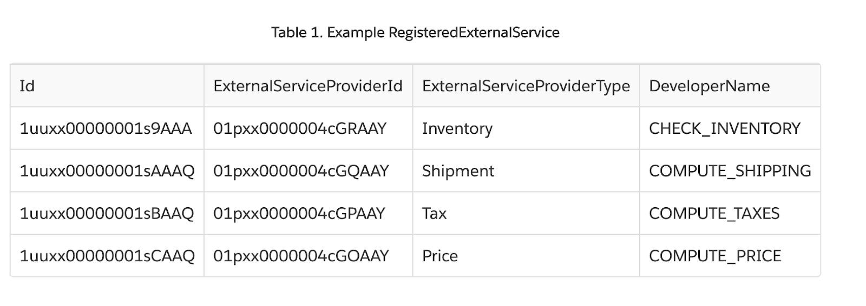

1. **Add Remote Site Setting Configuration**​ by going to Setup > Remote Site Setting
   1. Click ​**New Remote Site**​ button
      1. Name: ​**herokuapp**
      2. Remote Site URL: ​[**https://b2b-commerce-test.herokuapp.com**](https://b2b-commerce-test.herokuapp.com/)
      3. Active: ​**Checked**
      4. Click ​**Save**

## **Part C: Store Integration Service**

1. Map Integration classes to your store by clicking on ​**Stores**​ in the Commerce App main navigation
   1. Click the **Store**​ made earlier
2. Click the **Administration** tile

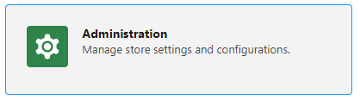

1. On the left had side select **Store Inventory > Link Integration**
2. Select the **Check_Inventory** class you created earlier

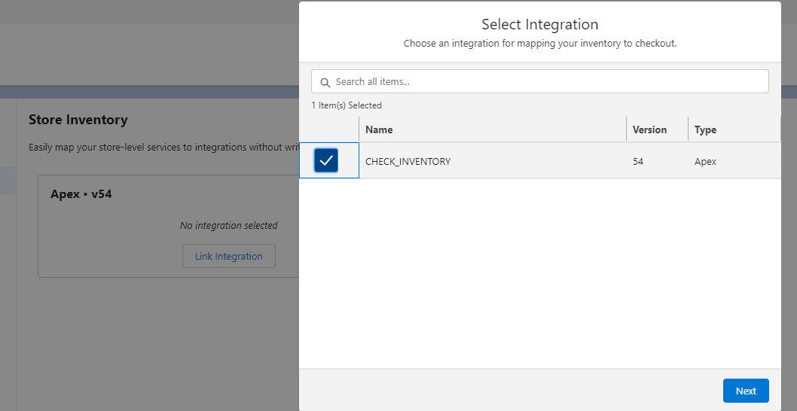

* 1. Click **next** and **confirm**

1. Repeat the above steps for **Tax Calculation**, **Shipping Calculation** and **Price Check** (Select **Compute_Price** NOT Standard Pricing)

Section 7: Activate Store!

## Part D: Activate Store

1. Verify that all the **Setup Store Assistant Steps are Complete**​. Indicated by multiple​ green checks (on right):

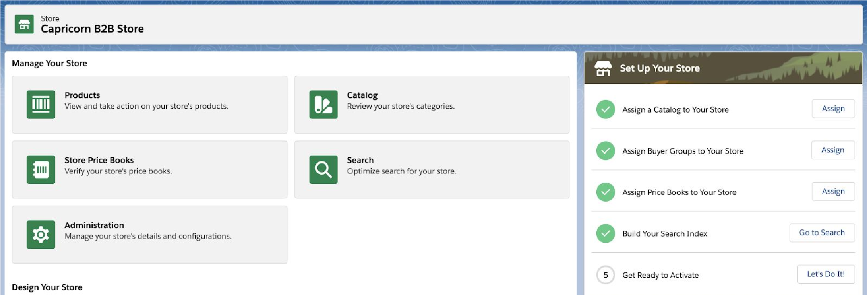

2.

Validate the Store Activation Checklist by clicking on the

​

**Administration**

​

tile:

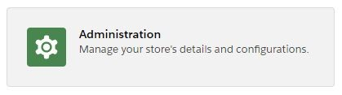

1. Validate that all the steps listed are indeed complete in addition to Store Setup Assistant:

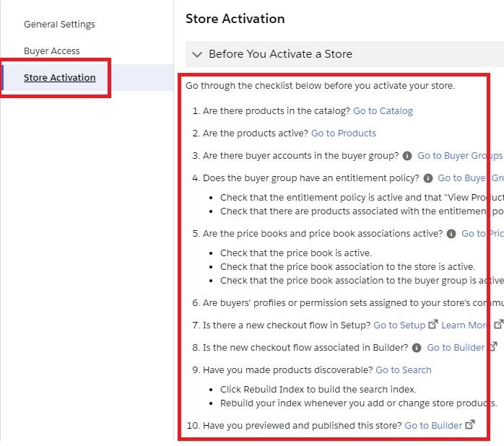

1. Click the ​**Activate**​ button and confirm the dialog by clicking ​**Activate** ​again​**.**​ This will also activate the mapped Community:

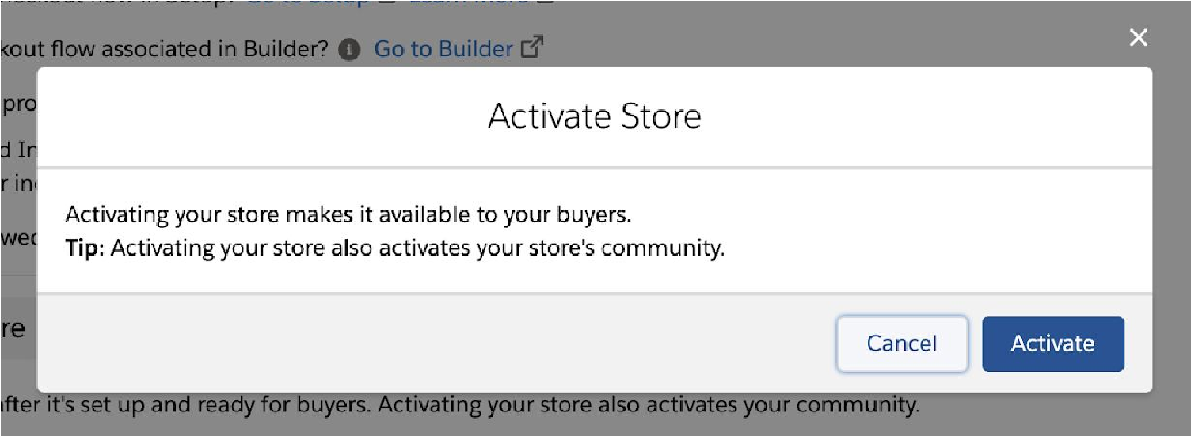

1. Confirm that you receive on screen message: ​*Your store was activated*
2. You should receive an email soon like: ​*Welcome to Your Store*

# Section 8: Explore the Storefront

## Part A: Access B2B Run time as Buyer

Assign Permission Sets

In order for a user to log in as a buyer they need the appropriate permission set applied.

1. Go to Setup > Users
2. Click the label that says ​**Contact 1**
3. Click ​**Permission Set Assignments**​ (top left)
4. Click ​**Edit Assignments**​ button
5. Use the right Chevron to move these permissions over:

a. B2B Commerce User

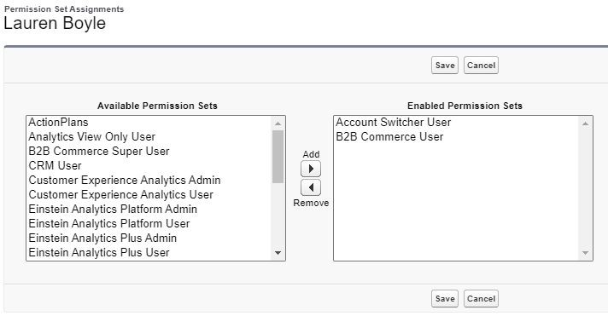

6.

Click

​

**Save**

7.

Click

​

**OK**

​

to confirm the dialog (if present)

Log in from Contacts

1. Log In as **Contact 1** (Buyer) by going to Commerce App > Main Navigation > Contacts

1. Click on ​ **Contact 1** ​ to open the details page:

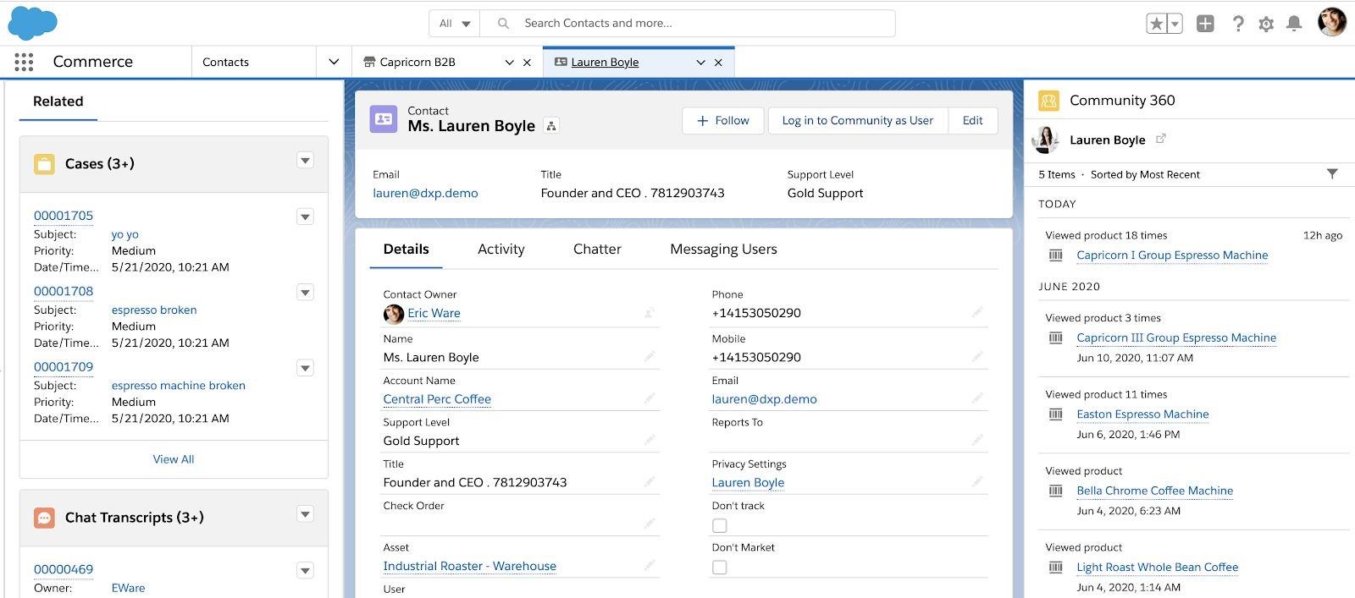

1. Click on **Log in to Experience as User**​ (top right)​
   * 1. If you don’t see this button you will need to add it to the page layout. This should be something you know how to do at this point 😊

2. Verify that the checkout flow is working properly as **Contact 1**:

1. Search from your Store Home Page for one of your products
2. View the Product Detail Page:

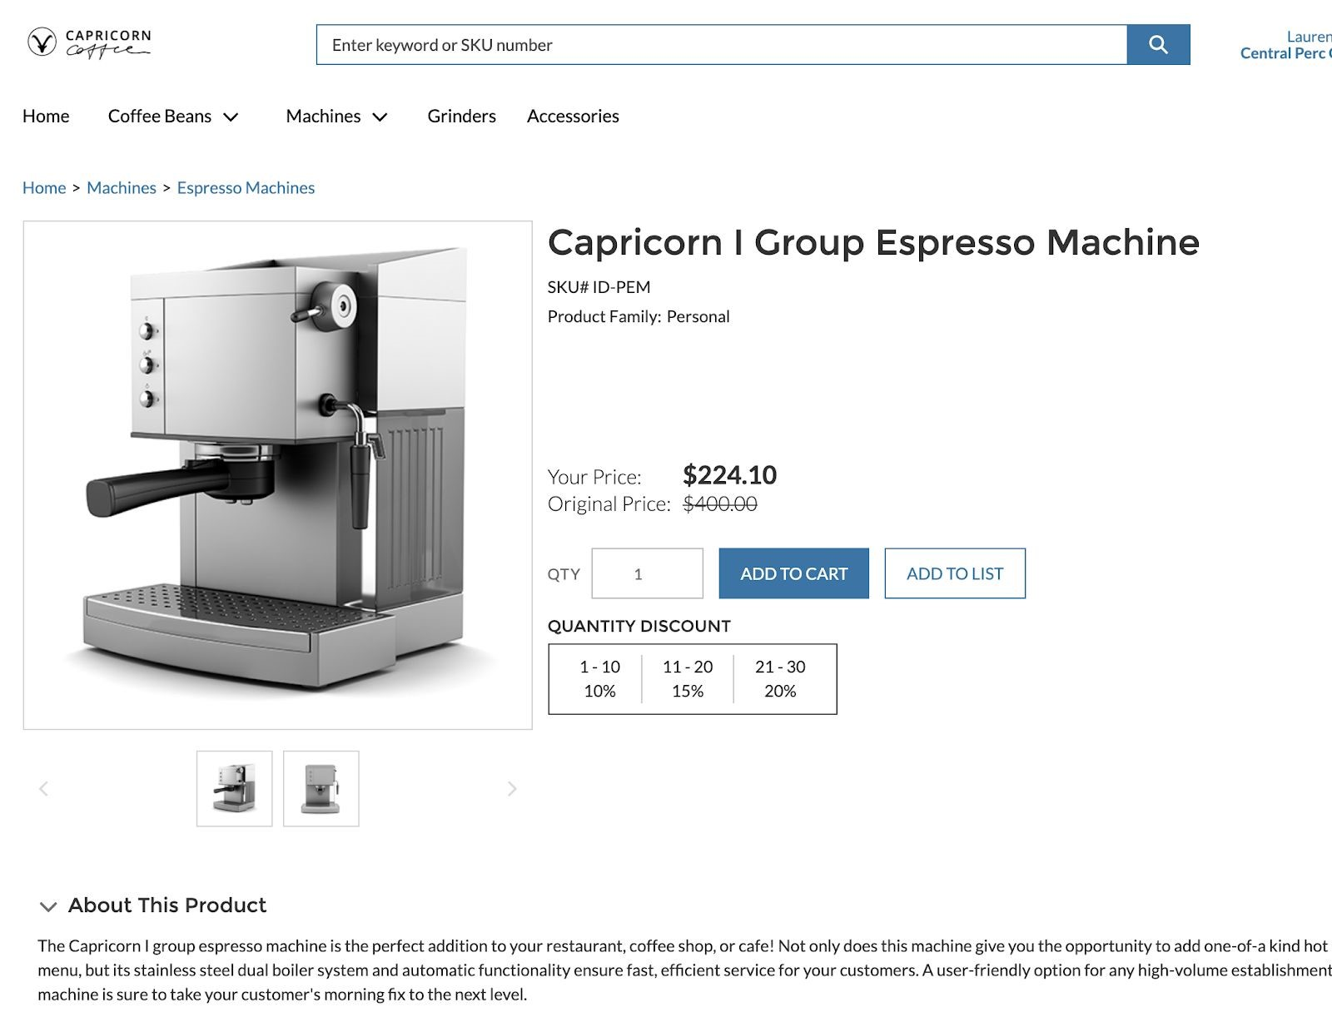

c.

Click

​

**Add to Cart**

​

button:

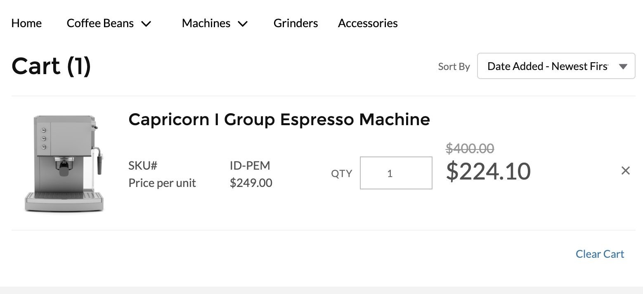

d.

Click

​

**View Cart**

​

button

1. Click ​**Proceed to Checkout**​ button
2. Click the ​**Next**​ button **ignoring any messages about Contact Point Addresses (We will create these in the next section).** Wait for all the processing to finish. You may see some alerts about updates happening for inventory, taxes, shipping, etc. in the background while getting a wait animation. This is normal.
3. Click the ​**Next**​ button
4. Enter a fake ​**PO number**​ like 100100100 ignoring any messages about Contact

Point Addresses

1. Click ​**Submit Payment** ​button
2. Confirm all steps are working as expected and troubleshoot them accordingly if they are not. You should end up with something like this when done:

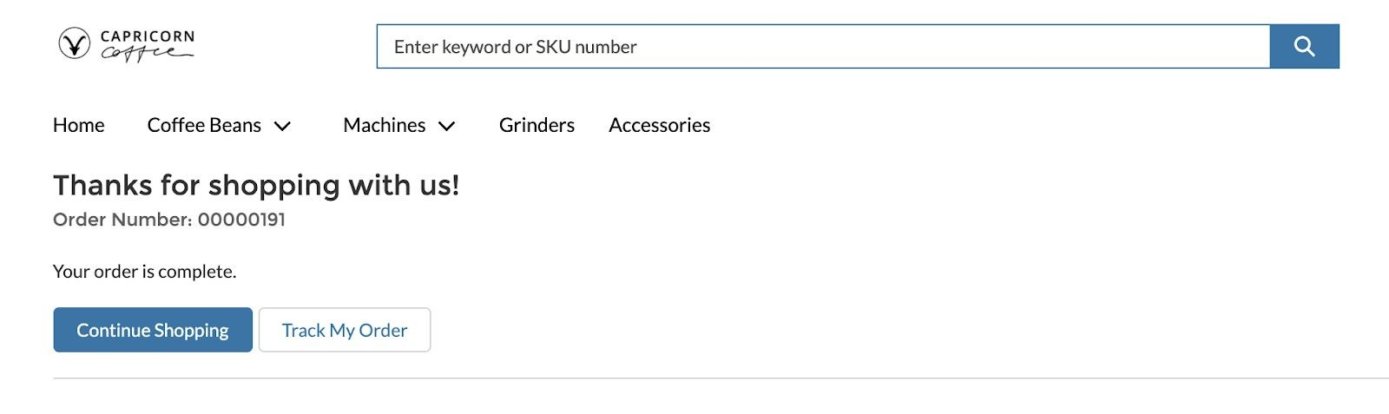

## Part B: Create and Assign Contact Point Addresses

1. **Create new Contact Point Address for Billing**​ by going to Commerce App > Accounts > Account A
   1. Click ​**Related**​ to access the related list entries for the Account (main record detail menu for Account)
   2. Click ​**New**​ under ​**Contact Point Address**​ Section
      1. Name: ​**Main Billing Address**
      2. Address Type: ​**Billing**
      3. Is Default Address: ​**Checked**
      4. Parent: Account A ​**(Pre-Selected Account)**
      5. Address/City/State/Country: ​**Choose as needed**
      6. Click ​**Save**

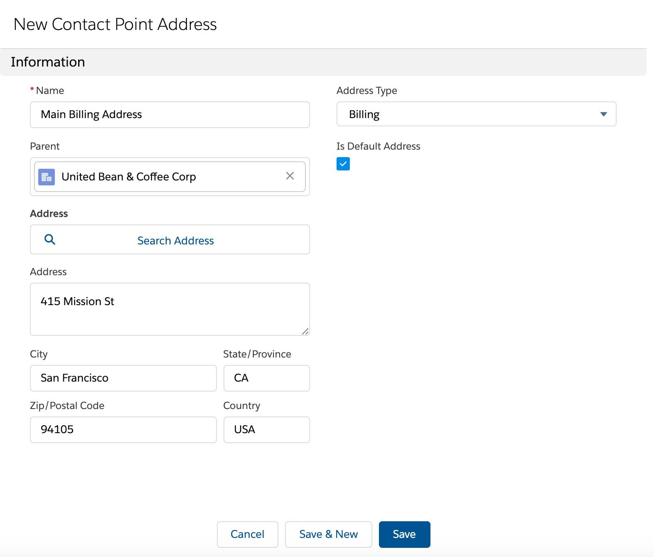

1. Repeat the same process to **Create a new Shipping Address as a Contact Point**​  **Address** by going to Commerce App > Accounts > Account A
   1. Click **Related**​ to access the related list entries for the Account (main record detail​ menu for Account)
   2. Click **New**​ under ​**Contact Point Address**​ Section​
      1. Name: **Main Shipping Address**​
      2. Address Type: **Shipping**​
      3. Is Default Address: **Checked**​
      4. Parent: Account A **(**​ **Pre-Selected Account)**
      5. Address/City/State/Country: **Choose as needed**​
      6. Click **Save**​
2. Contact Point Address matches with Account Addresses and NOT Contacts, and is the default way to associate addresses to Accounts in B2B Commerce Lightning and is also how Checkout is powered.
3. You should have the Contact Point Addresses section completed after this part is completed (example view below)
   1. Make sure to add Contact Point Address as part of the Account page layout if not already done as part of Pre-Work prior to this.
   2. You can have multiple Shipping and Billing Addresses assigned against an account, and assign one of them as default each for Billing and Shipping Address
4. Complete another checkout to view your new Contact Point Addresses

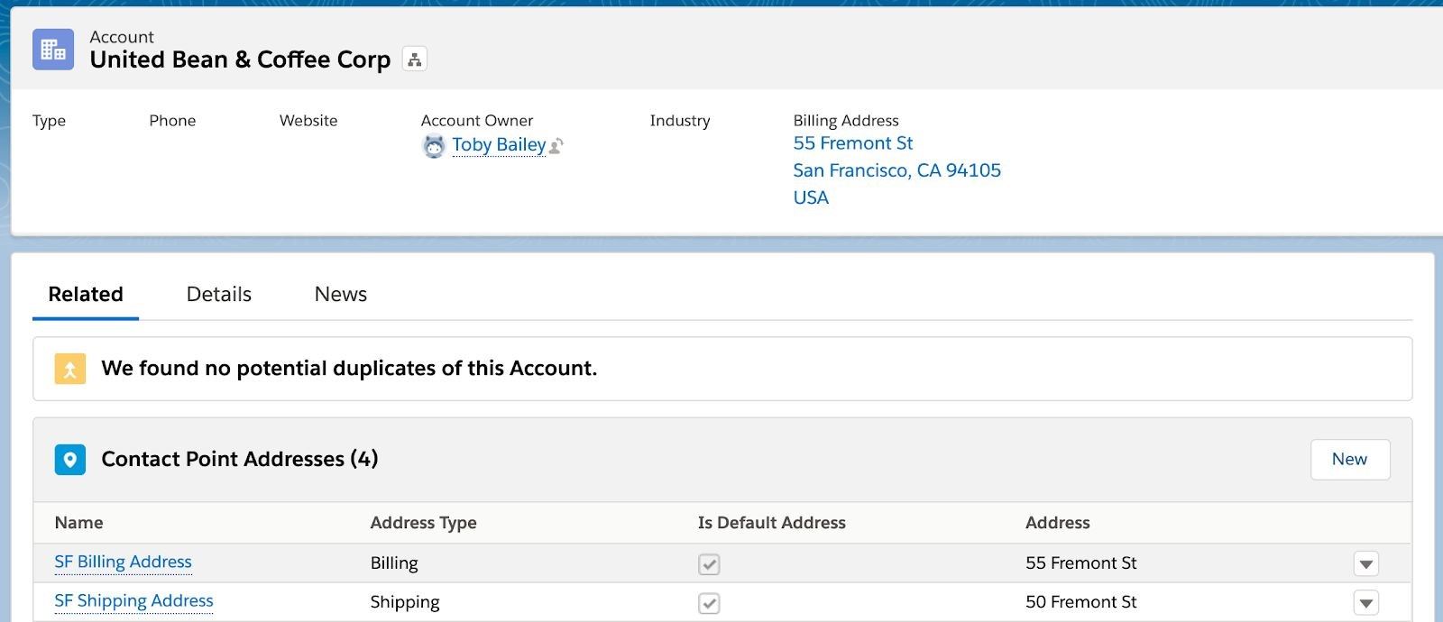

Congratulations! That is the end of the exercise guide ☺